Before starting, set below. It will show all the errors on the top of the dashboard page.

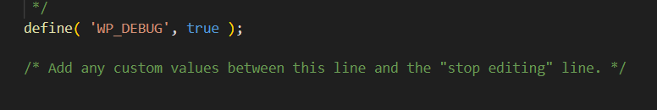

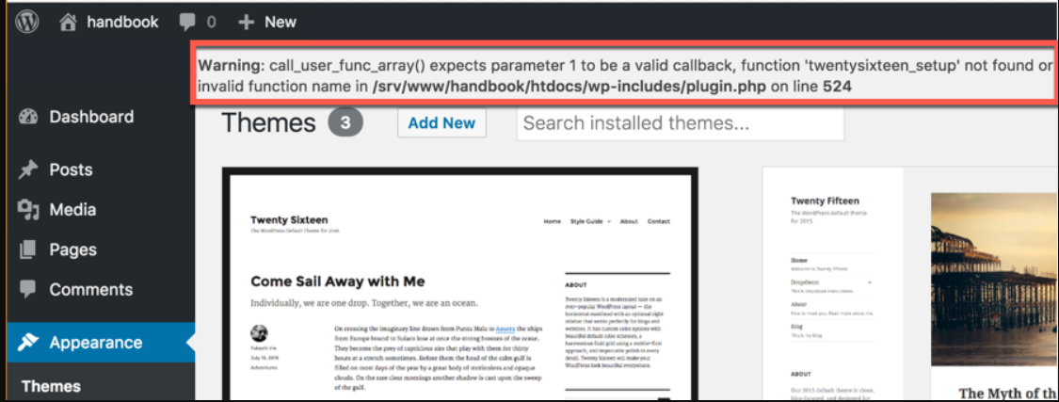

1. Create structure and all required files including template, inc folders.

<https://developer.wordpress.org/themes/basics/template-files/>

1. Add **wp_head()** and **wp_footer()** function in the pages. For this add them to header.php and footer.php respectively and then using the get_header and get_footer functions add them to all the pages. Without them you will not be able to add the css or script files. They will load all the required files in the header and footer.  
     
   **wp_head()** will add all the style, script , seo etc. before the closing of the head tag.

**wp_footer()** will have bit more javascript. Both these are required to make the themes and plugins work properly.

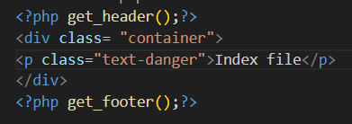

1. Enqueue style and script using wordpress hook. Make sure all hook spellings are correct.

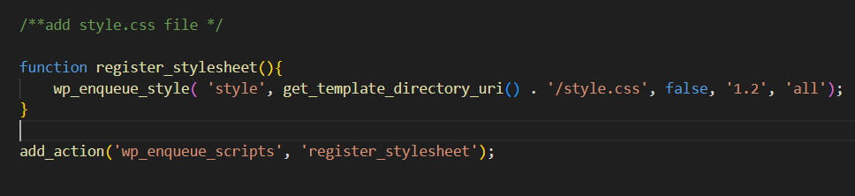

1. Add bootstrap and jquery cdn link

**Make sure you add your own style.css after these files otherwise they will override your css. It means point 2 will come after point 3. Jquery should be added before bootstrap as it is dependent on jquery**

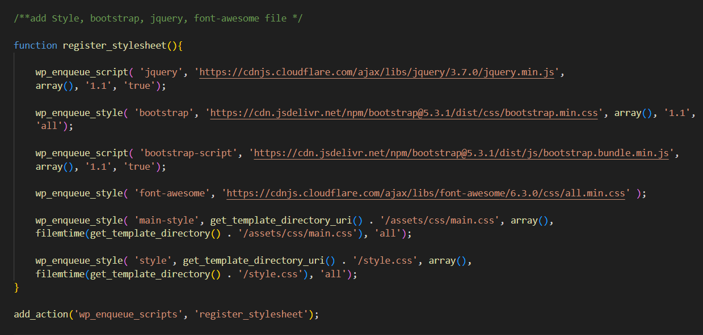

1. Instead of creating separate functions, we can add them in one function I have also added fontawesome cdn. Make sure the last file is your style file added.

**Use time() function for version, it will update it everytime**.

1. Add all the necessary theme support. For example, if you go to your website and edit post, you will not be able to see the **Feature Image option** to add, for that we need to add the theme support function. Similarly, in customize you **will not** see the **option for Logo**, we need to add theme support for logo too. So Add theme support for all the required options.   
   You can get all the theme support functions from here:

<https://developer.wordpress.org/reference/functions/add_theme_support/>

You can add them without creating the function, then they will initialize when the theme loads with init hook. Otherwise you can create using the following structure.

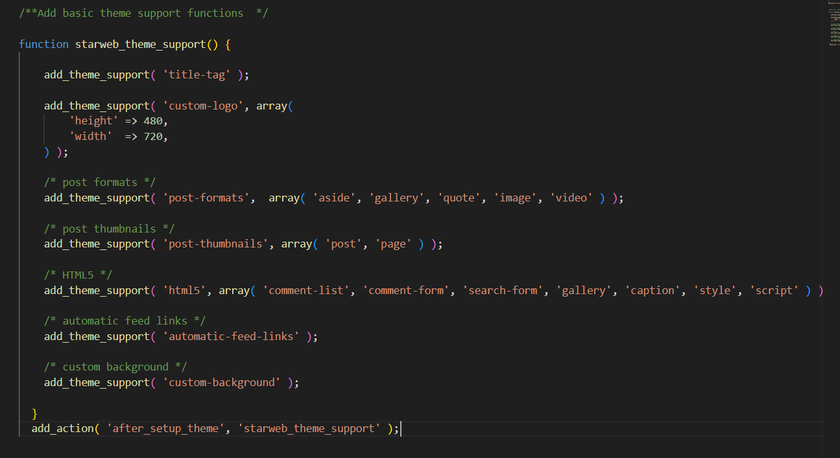

1. **header-custom.php** : get_header() function automatically get the **header.php** file. If you want to create a separate header for a separate template file or page. You can create the file, for example, **header-landing.php** and then in the new page or template file you can get this header by **get_header(‘landing’) .** If in case header-landing is deleted it will show header.php because that is fallback file for all the headers.
2. **footer-custom.php** : same as header you can create different footer file for different pages.
3. Add **theme.json** file to the core of wordpress theme. With this you can set the universal css variables, you can also set the colors and fonts for the blocks in the dashboard in pages and posts. You can change the default settings for blocks color pellets and fonts.

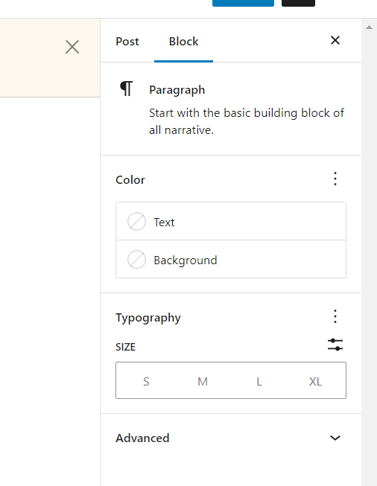

You can also change the other blocks. For example : By default we have that many colors in the Cover block which we can change by theme.json file and set colors of our own choice.

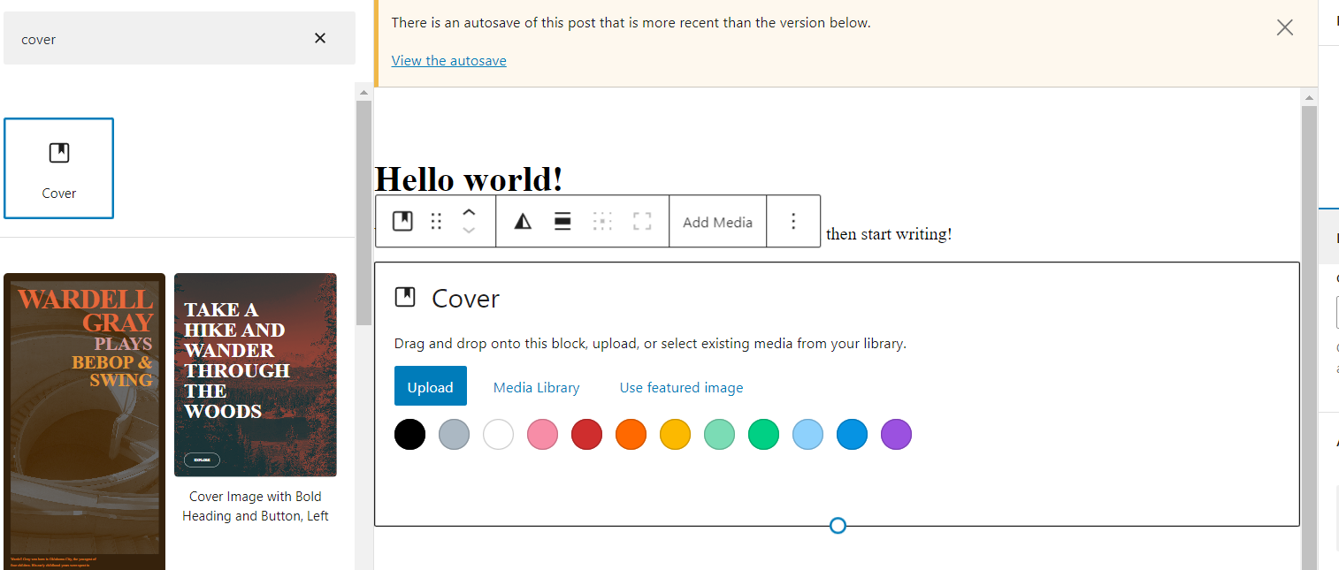

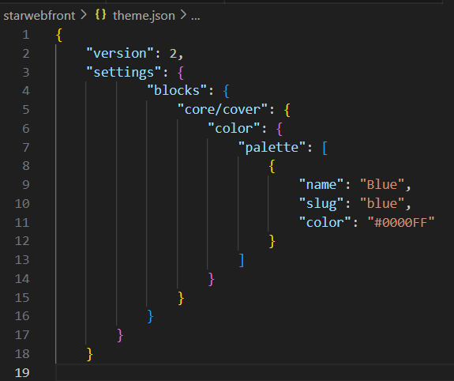

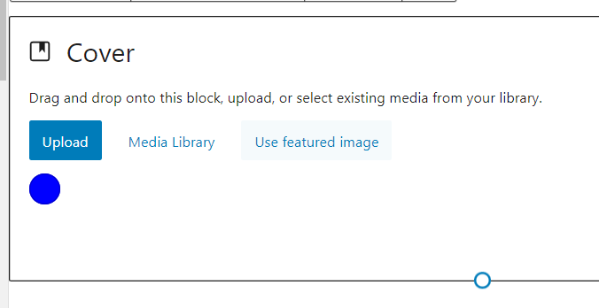

<https://developer.wordpress.org/themes/advanced-topics/theme-json/>

<https://www.youtube.com/watch?v=sj056Au1bQI>

<https://richtabor.com/standardizing-theme-json-colors/>

1. Template Parts: As the files keep on increasing, it is better to create the folders and split the files.

For example: we can add files to **include** folder for displaying the content and can get them inside the pages using **get_template_part**. If we have a file inside the includes named **section-content.php** then we can add them in the page using **get_template_part(‘includes/section’, ’content’);**

**Front-page.php is responsible for the front page and page.php is responsible for all other pages to display content.**

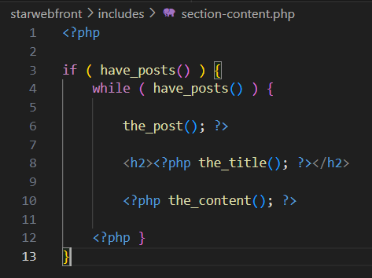 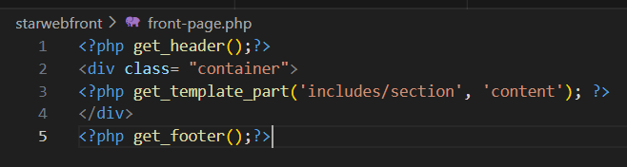

If we have a different layout for the page, then we can create a separate template file and name it as **tempate-filename.php (for ex. template-contactus.php)** and we can set different template for that.

The template will be added here but only after adding the template name in the comment on the top of the file.

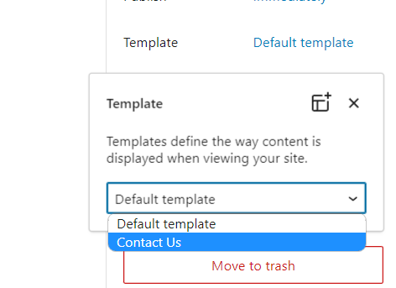

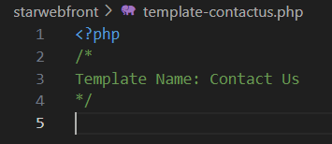

1. **Navigation :** First register menu using register_nav_menu() function in functions.php file to display the menu option in the Appearance.

<https://developer.wordpress.org/themes/functionality/navigation-menus/>

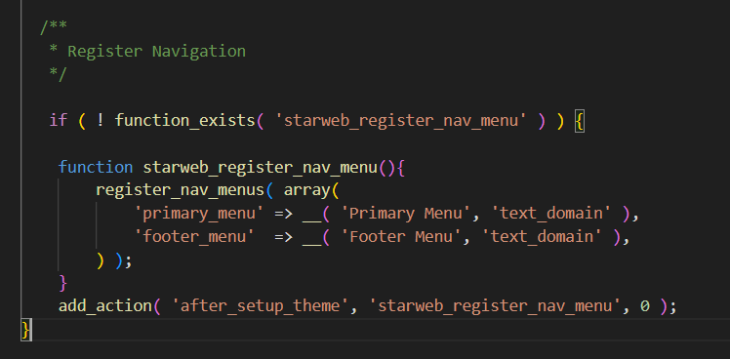

**And then use**  [wp_nav_menu()](https://developer.wordpress.org/reference/functions/wp_nav_menu/)  function to display the menu wherever you want to show, mostly in header.php file and footer for footer menu. You can add all the classes using the extra parameters for array in wp_nav_menu from this link

<https://developer.wordpress.org/reference/functions/wp_nav_menu/>

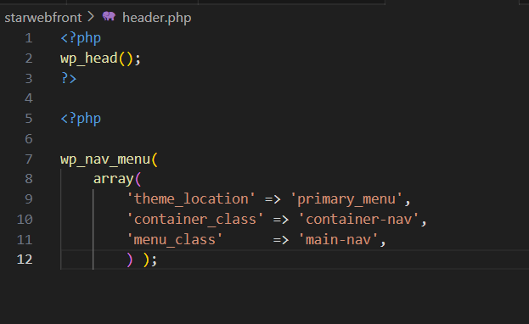

1. Add **body_class** to display the different classes in the body tag of each page.

Also add wp_body_open() , it is important for the best practices and adding the code before the openeing of body tag . Useful to make plugin and themes work properly.

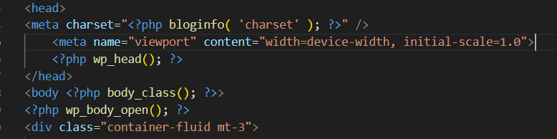



1. Make your header.php looks nice using the bootstrap and add custom logo and menu.
2. Work on navigation, use bootstrap classes to add on **li and a** tag, which we cannot add using the wp_nav_menu. So we will add them using the filter provided by wordpress. So we have two different examples, one with li and second with a tag.

Add in the header.php

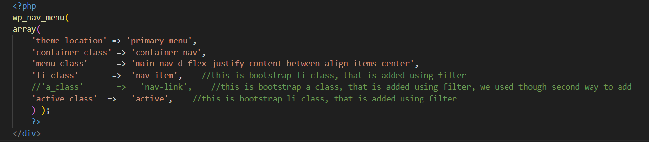

Add filters in functions.php

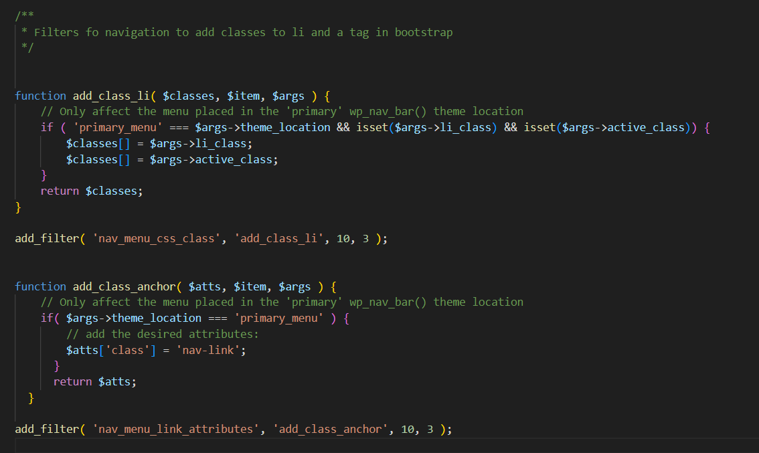

Reference : <https://www.youtube.com/watch?v=wAHjD8L7Be4>

<https://developer.wordpress.org/reference/hooks/nav_menu_css_class/>

1. Index.php: Will be responsible for displaying all the posts in one single page.

For example, if you have different posts of different categories they will display on index.php page using loop. If you have set Blog as your post page in the settings. If home.php file is present it will take the priority over index.php.

<http://localhost/wordpress-class/blog/>

1. Archive.php : Page is responsible to display all the posts that are displayong from a particulare category. For example: <http://localhost/wordpress-class/category/web-development/>

This will display all the posts from the category named web development.

To make the permalink user friendly, like <http://localhost/wordpress-class/blog/seo/> , we can fix it inside the Setting-> Permalinks

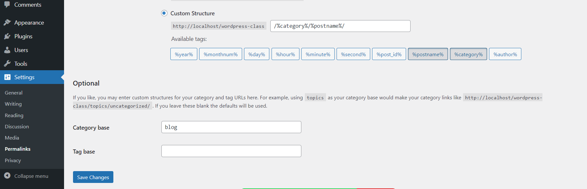

You can set the category base for the categories to display the page name blog. You can also set the Tag Base for the tags.

**But this can create an issue and your pagination will not work if set for the main blog page because blog page and setting category base as blog will lead to conflict in permalink.**

**So, either set the Blog to Blogs in the page and keep category base as blog.**

**Or use Another way you can create Blog as Parent Category instead of Page. And then you don’t need to set the Category base.**

<https://wordpress.stackexchange.com/questions/44537/why-is-page-2-not-working>

1. Fix more things in archive page to look the posts better on the page and adding read more button.   
   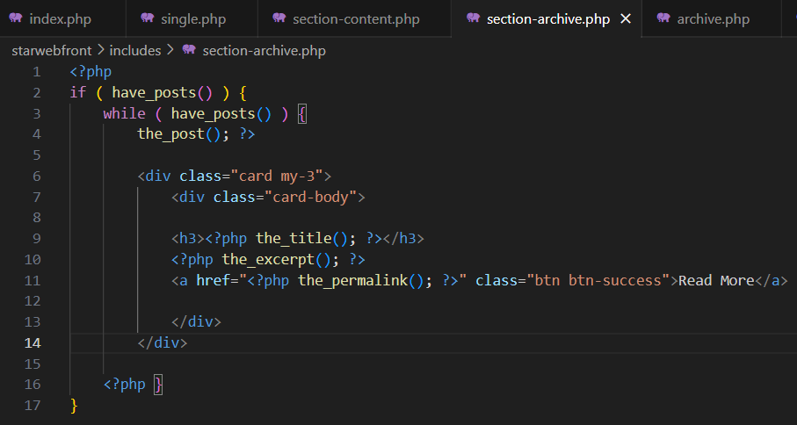
2. Pagination in the post page: single category page and main blog page.

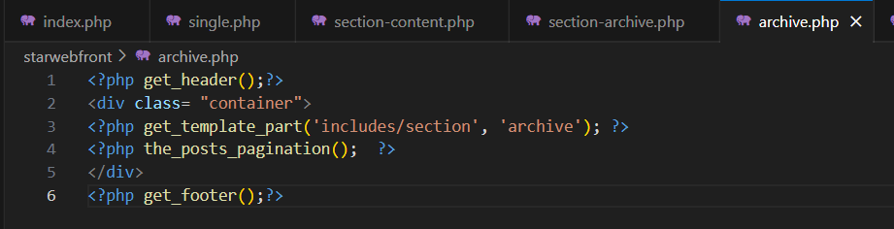

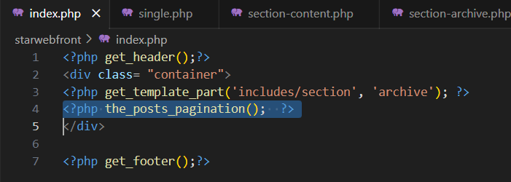

1. Archive.php is the base for all the categories. If you want to make a separate design for a category, you can create template file using category as the first name. For ex, if we have seo category, we can create template for **category-seo.php** . You can modify it as you want.  
     
   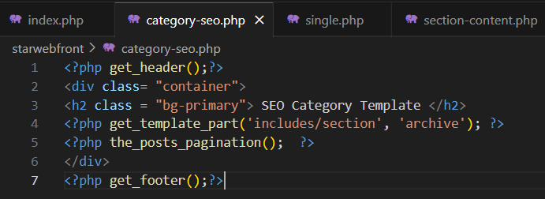
2. Add all the required tags in the singleblog page. For example, featured image, author to dispay, tags, categories in the page. <https://codex.wordpress.org/Template_Tags>

Set the featured image on single page, you can set the sizes for images in functions.php file

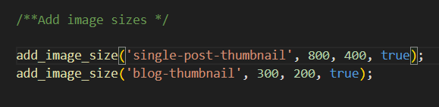

But they will work with the_post_thumbnail 

Learn more about it: <https://www.wpbeginner.com/wp-tutorials/how-to-create-additional-image-sizes-in-wordpress/>

We have used different way in single.php to add bootstrap classes and alt tag for images.

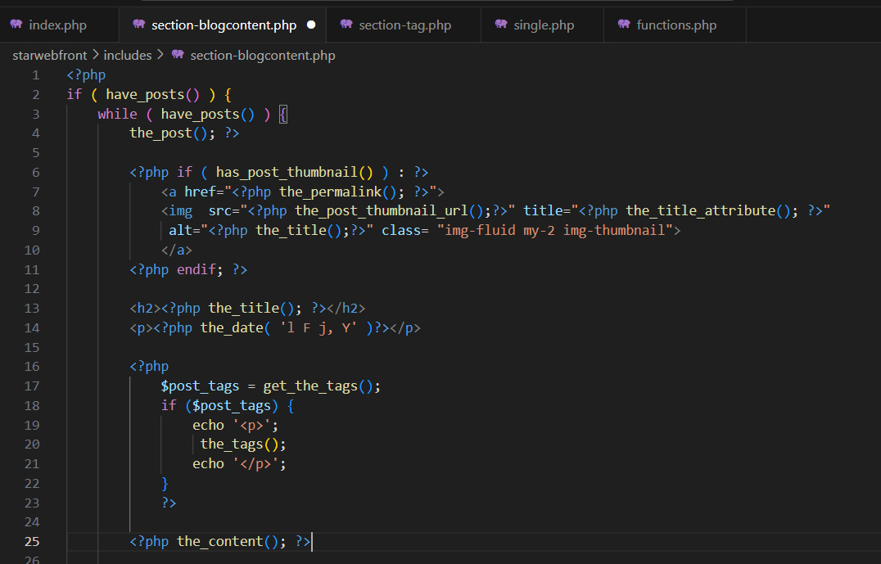

You can style image with bootstrap and css, then add title tag to display the title, then date tag to display the date and then we will also get the post Tags.

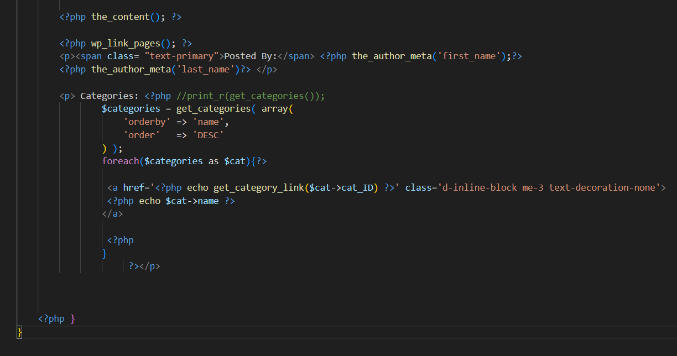

Then we have page link tag if we have a page break in the admin panel in the post, then the single post can have multiple page links.

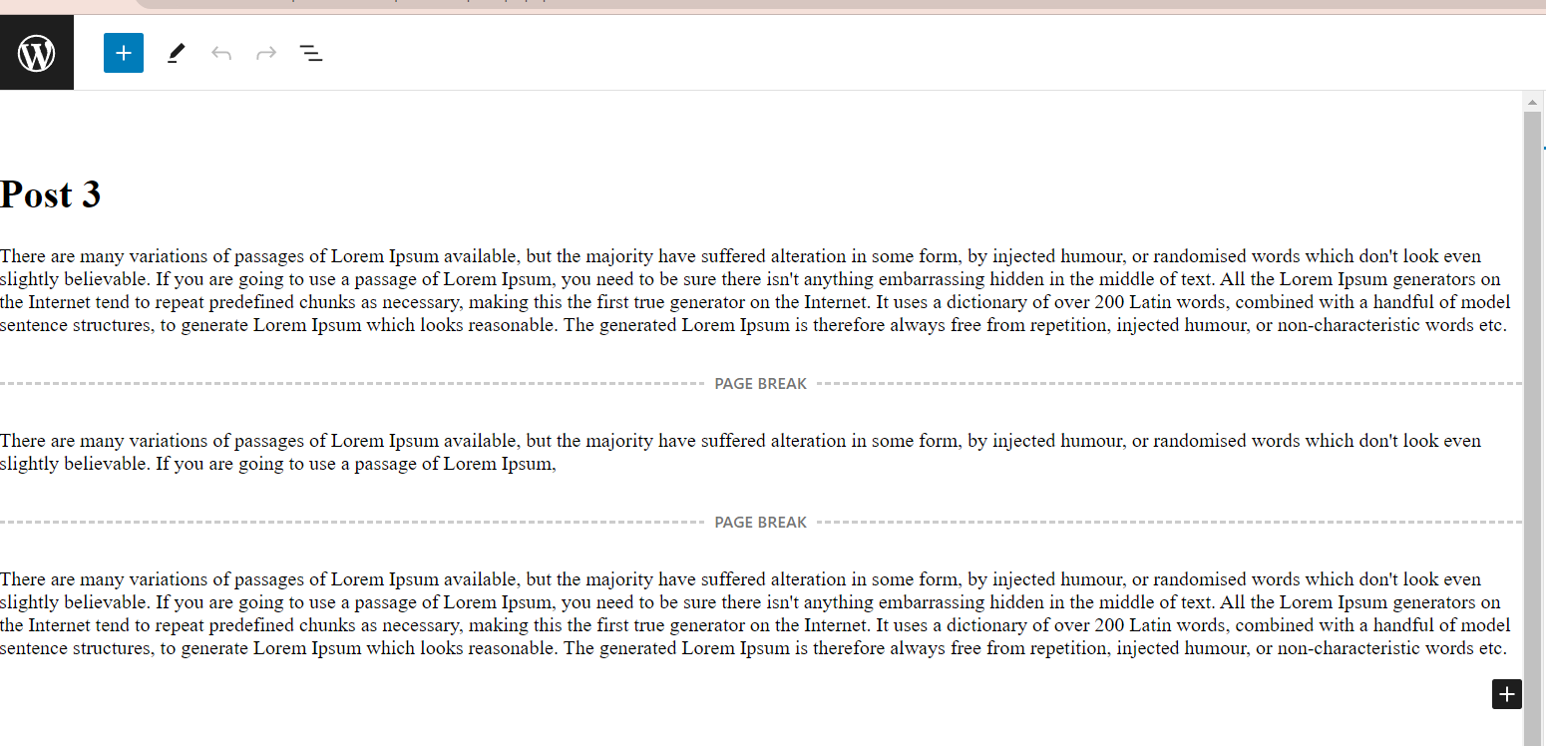

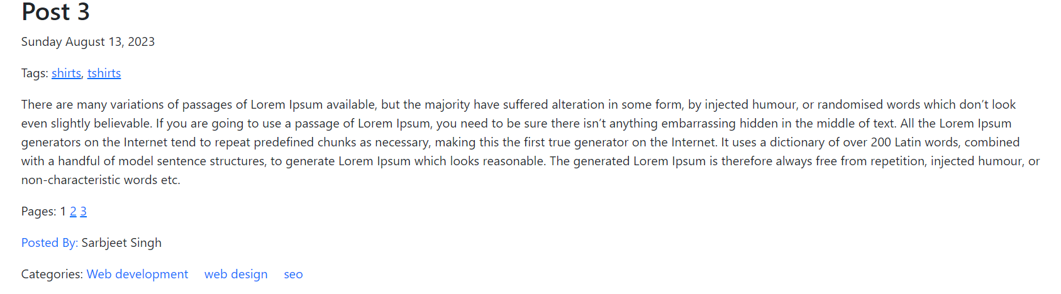

**Then at the bottom of the page we have categories links, it will display all the categories, on clicking the category it will open that category page with all the realted posts to that category. It will lead to the archive page.**

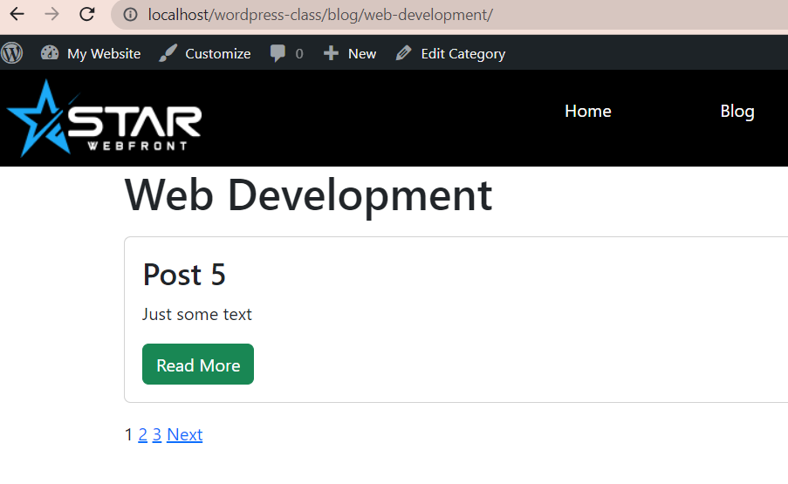

**Similarly we have tags, we can create a tag.php file and it will display all the posts related to that tag.**

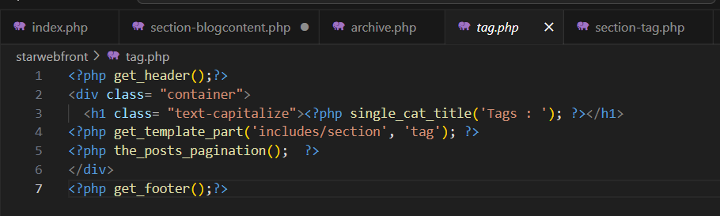

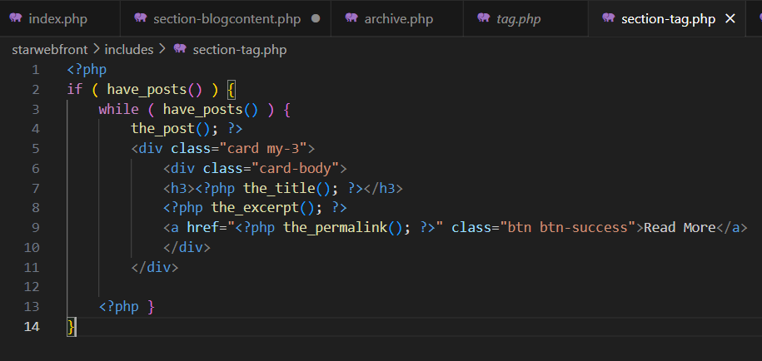

**For comment Section:**  Get the comment code from <https://developer.wordpress.org/themes/template-files-section/partial-and-miscellaneous-template-files/comment-template/> , create a comment.php file and add the comment code of 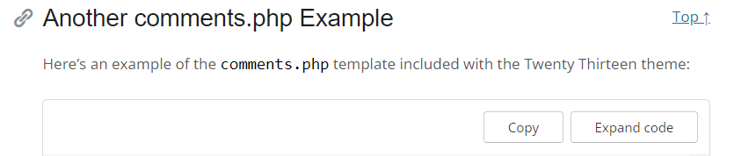

And then display it in single.php file using code from same theme devlopment link.

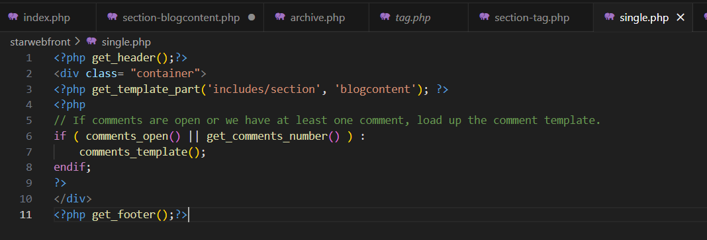

You can add images to the archive page and fix with css.

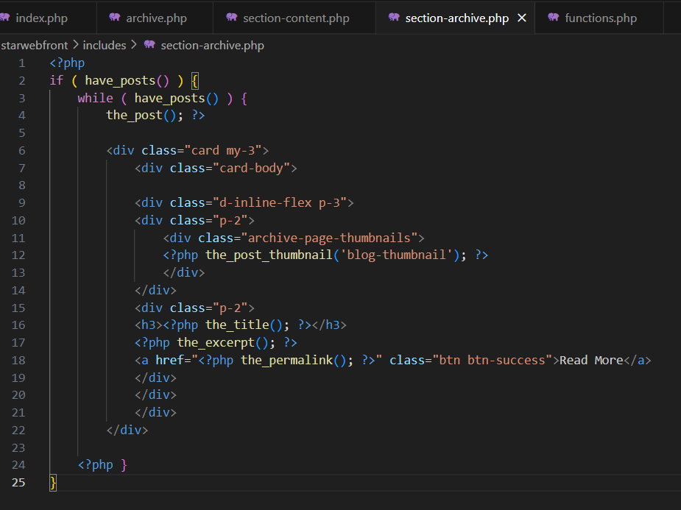

Same way you can add the images to all the pages.

1. Widget: First you nedd to add theme support for sidebars.

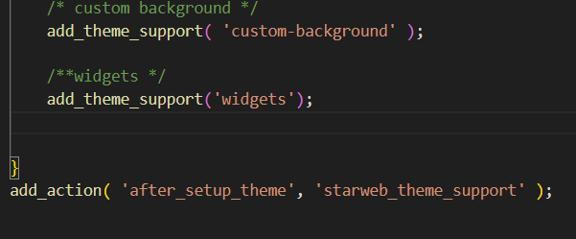

Then, register siderbar in the functions.php.

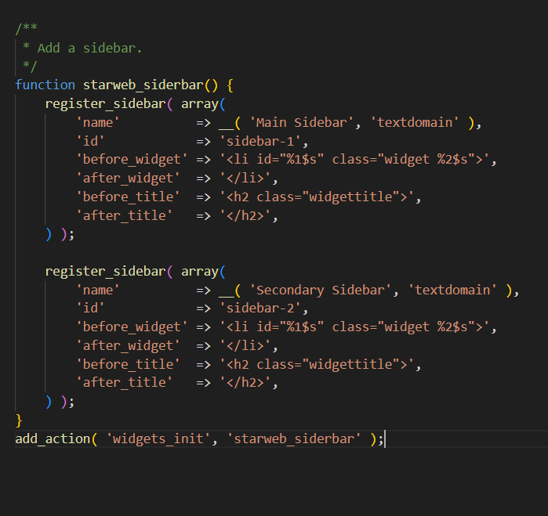

Then, display the sidebar in the pages, posts. Use the id of the sidebar. Then style the page

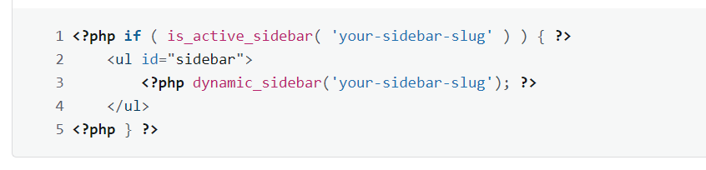

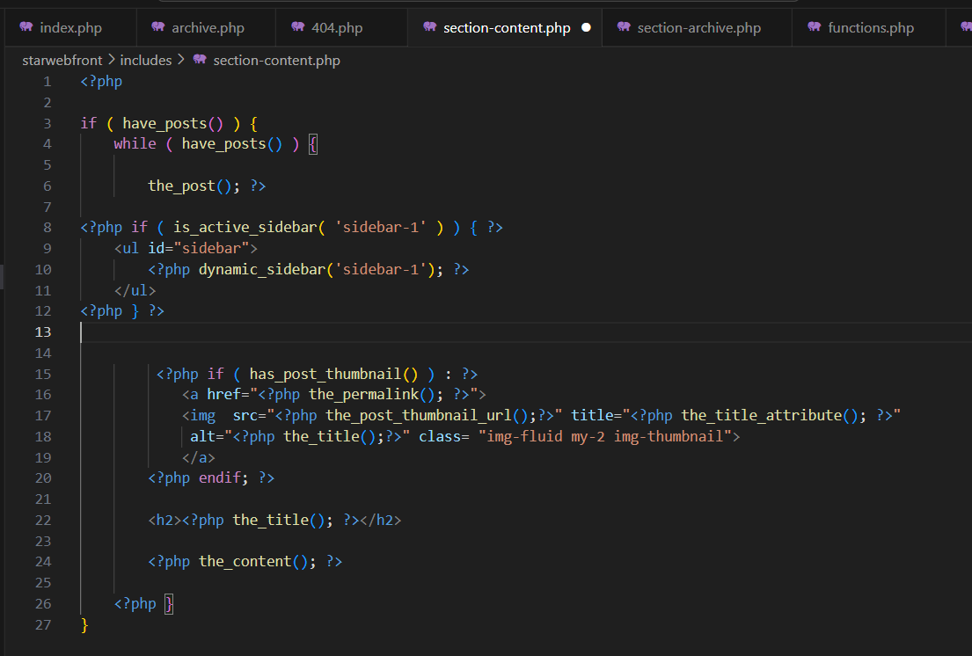

<https://developer.wordpress.org/reference/functions/register_sidebar/>

1. Search Form: You can easily add search form by using tag, **<?php get_search_form(); ?>**

You can create a search.php page and simply display the content like the archive page, so it will automatically find the result and show.

In our example we have write it in 404.php file. Get that 404 from theme development.

If you want to create a custom design for the search results, create a page named search.php and just simply loop the content and style as you wish. So it will ride default archive.php file.

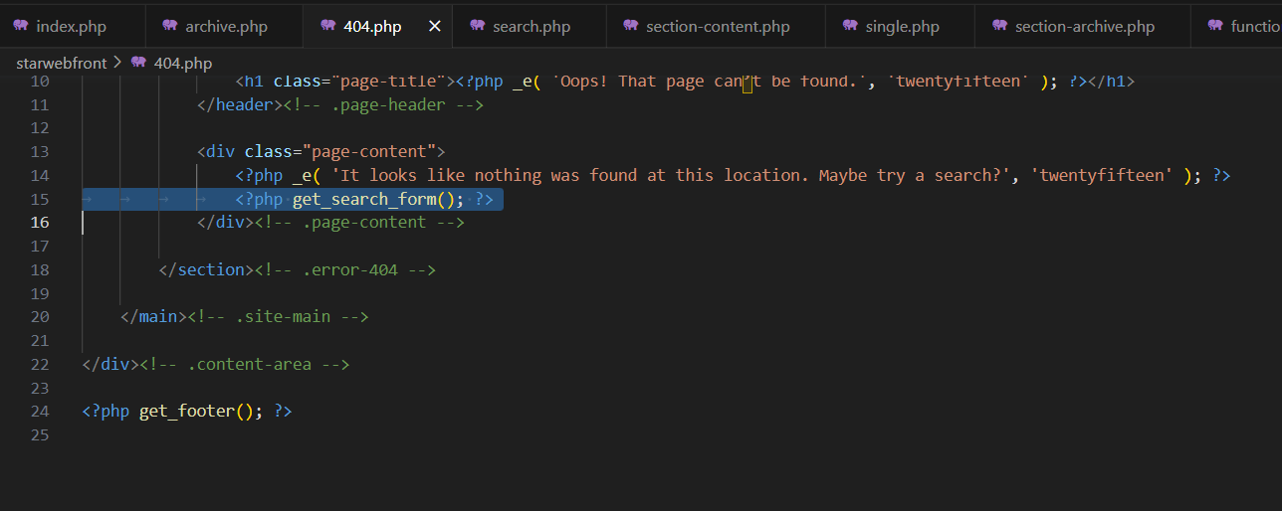

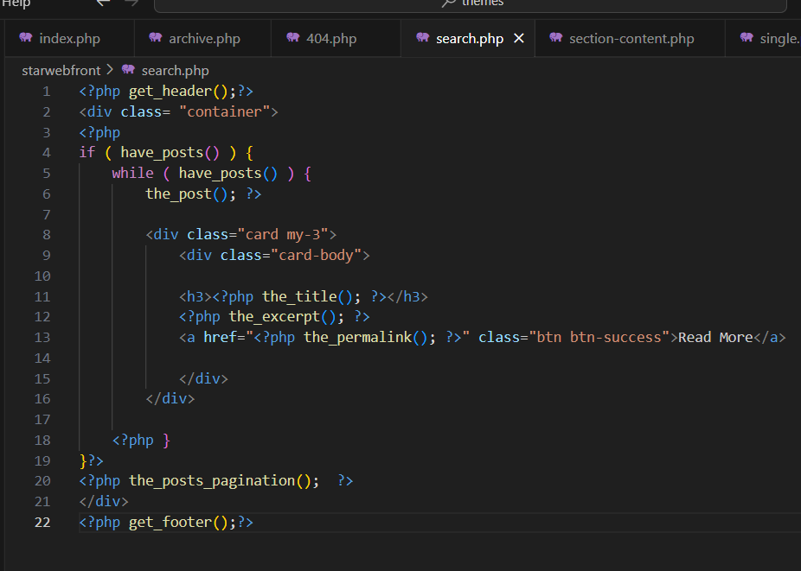

On 404 page, the search form shows like this :  
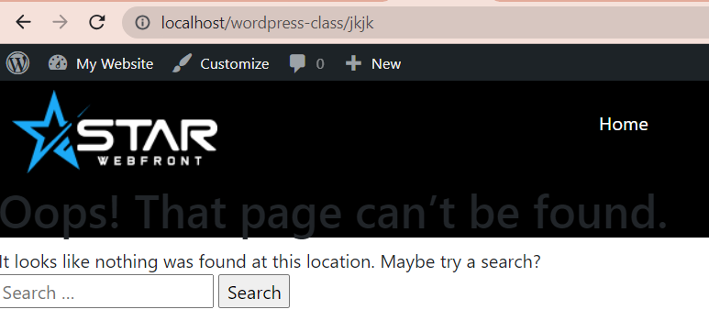

But if we create a searchform.php file, then this form will disappear because searchform.php file will override this and we can create our own custom search form inside searchform.php file. Which is useful if you want to search in a particular post id or any particular tags etc.

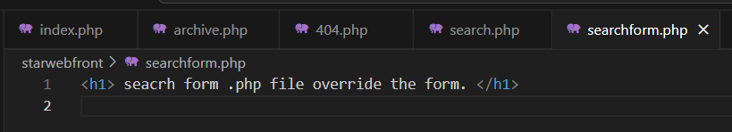

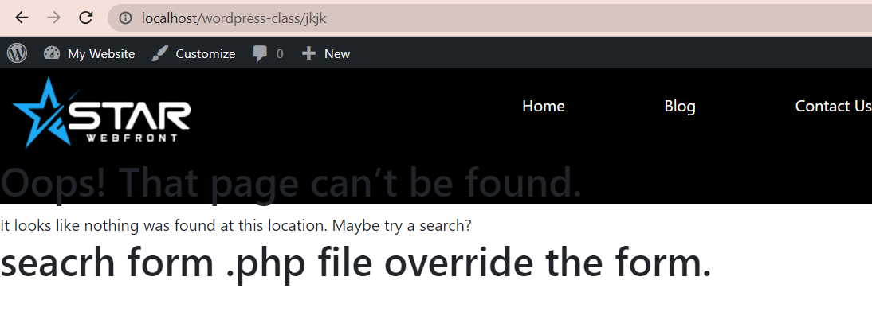

Now create our own search form in searchform.php

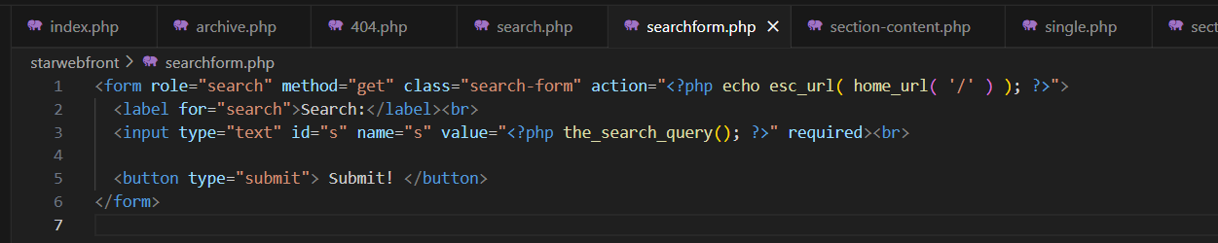

You can add the **<?php get_search_form(); ?>**  wherever page , post or 404 error page you want to display this search form.

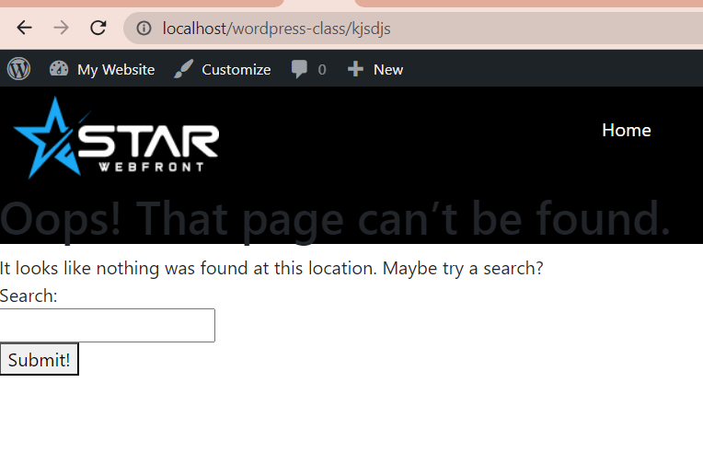

You can style it as you want.

Then you can add more hidden fileds if you want to search the result in aprticular category or tag using category id which is tag id, on hovering the category name. Then add that in the hidden field and it will search the result in that category.

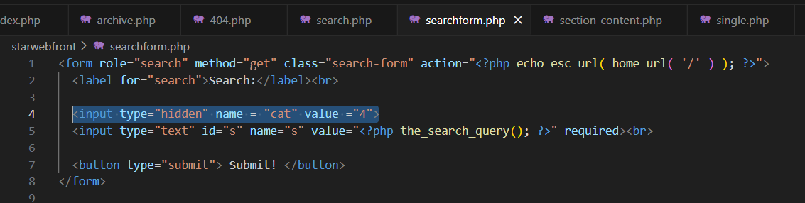

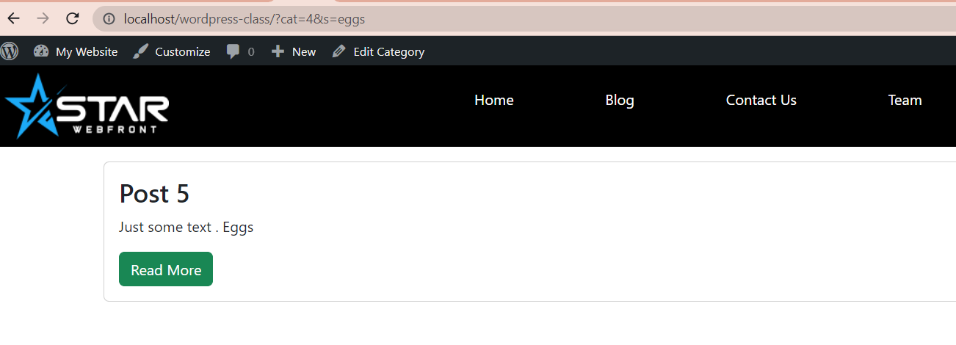

You can check in th url the category id. You can search multiple categories by adding more than one value.

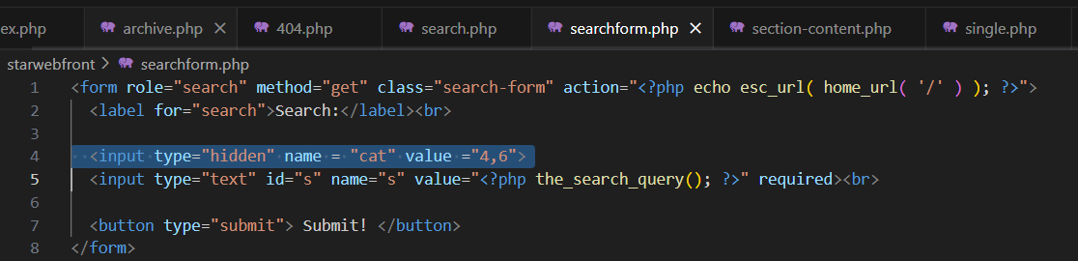

<https://www.usablewp.com/learn-wordpress/search-functionality/how-to-build-a-404-page-with-a-custom-search-form/>

1. Create Custom post type:

First register custom post type, in our case we name it Projects.

<https://developer.wordpress.org/reference/functions/register_post_type/>

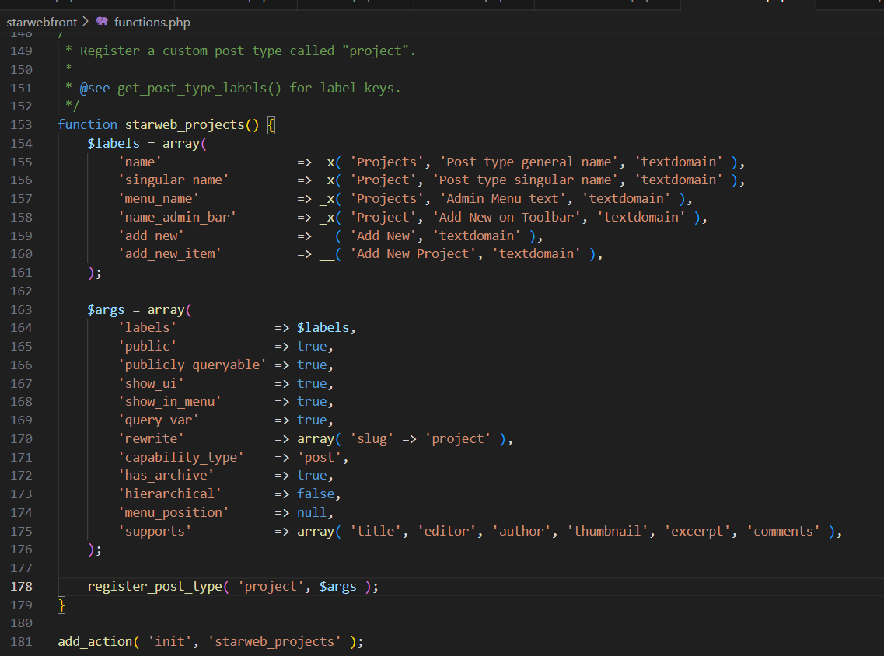

Add custom taxonomyu like categories, tags. If we set hierarcial to true it will behave as categories and fase will as tags. 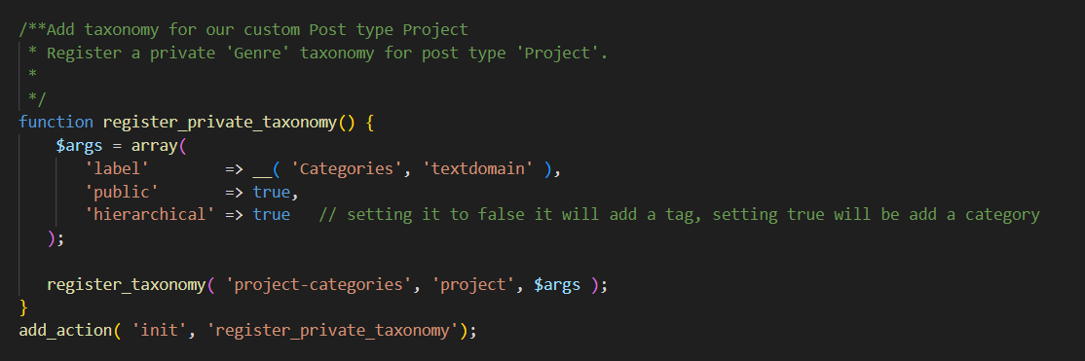

Now adding the page in projects by default works as single.php, But if you wan tto set a different page you can set single-project.php , where project is the id. 

Wordpress will first look for this page if it does not exist then it will be single.php

**If the page, don’t display or give error. Save the permalinks in setting.**

The featured image is not showing on the add project page, for this to work you need to edit function.php file where you add theme support for post_thumbnails, over there, add the support for your custom post type also.

**add_theme_support('post-thumbnails', array('post', 'page', 'movies','the_name_of_your_new_CPT')**

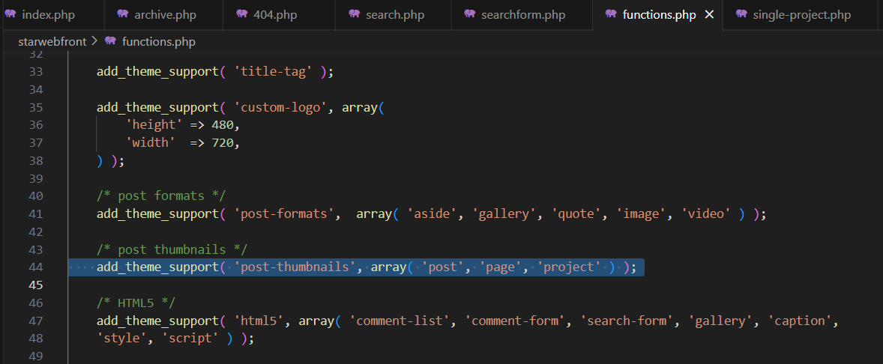

Now we have created template for single page but it is also showing the categories of the blogs. To make it to display the categories under the single project post related to project not blog. Add the taxonomy in the array and the taxonomy name.

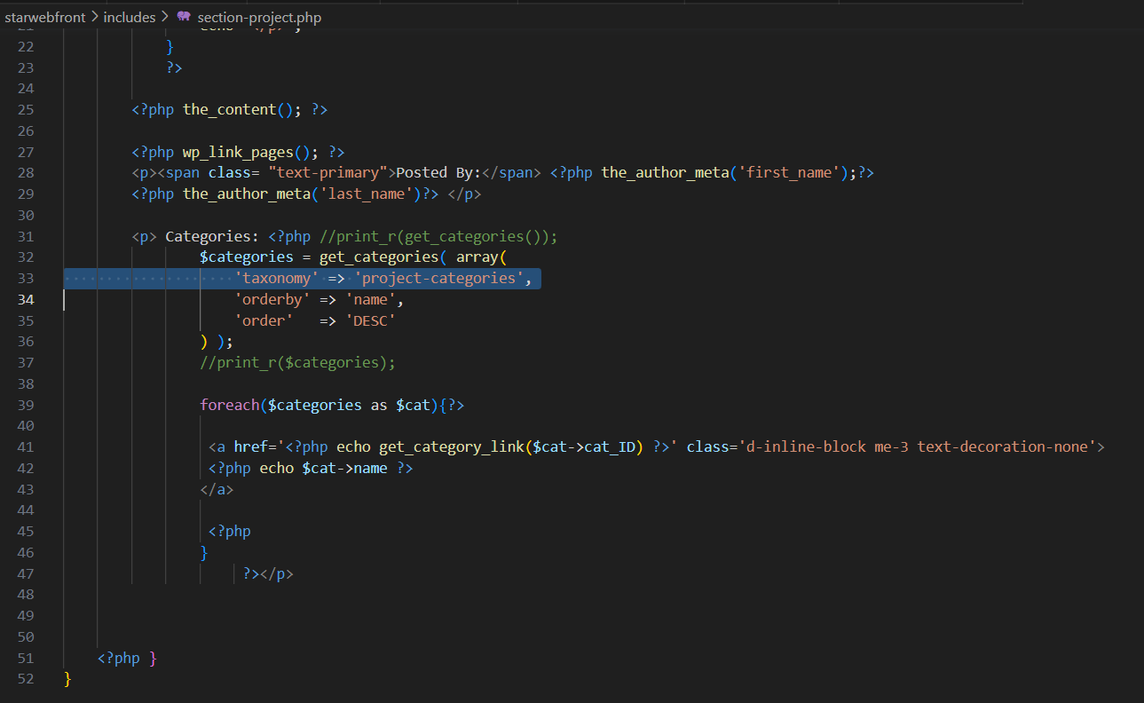

When you click on the category it will take the archive.php. You can create different archive-project.php file to display all the posts.

1. **Ajax with Form :**

Lets start from the beginning, we created a form inside the form-inquiry.php template which is then added to the sidebar of the page using tempalte_parts.

In form-enquiry.php, create an html form

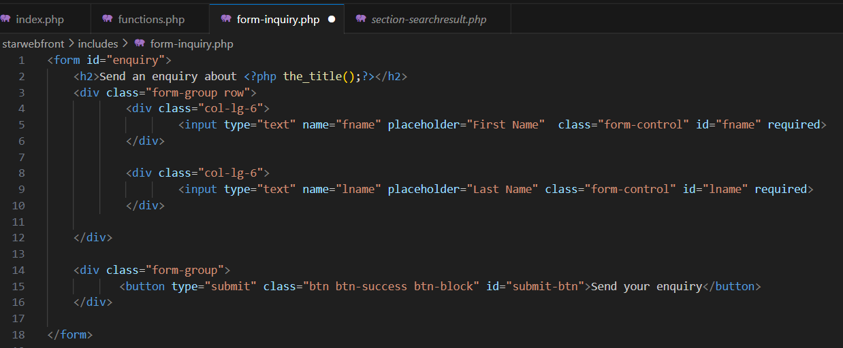

Then we create a script tag under this, and create an Ajax request to submit the data. See the code then we understand it step by step.

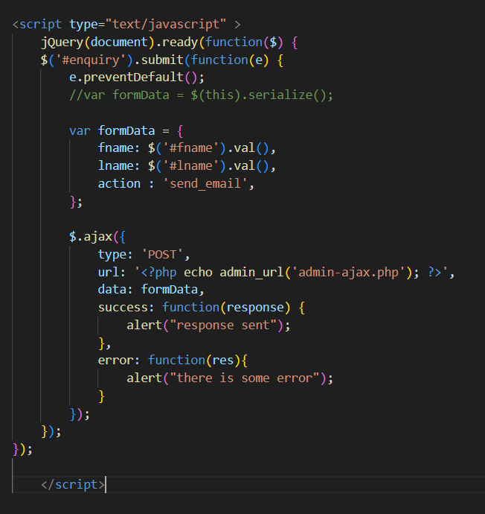

First we target the form with submit method and prevent the page from refresh by using preventDefault method.

Then we get the form field data and store in a javascript object, fname and lname.

We are storing action in a string, this will be also with data. It will be used in functions.php in two hooks to successfully complete the request.

As , AJAX is already included in the wordpress, we just need to print it in the url using wordpress function.

Then data will be the data that is stored in object along with action.

Success message will get the response if the request is successul.

Error will print any error.

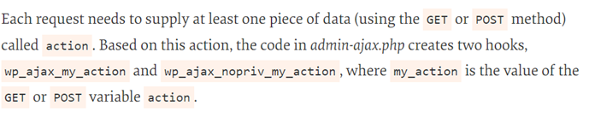

Nest step is to go to functions.php.

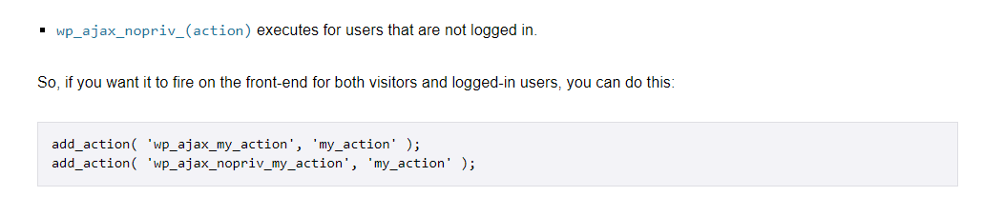

In our case action is send_email. **Action is must to send with ajax request.**

And then you need to create a callback function which will run.

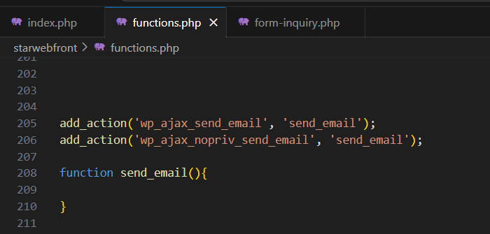

In the function we will process the data but first test this and you can check the response in Netwrok tab and also alert box.

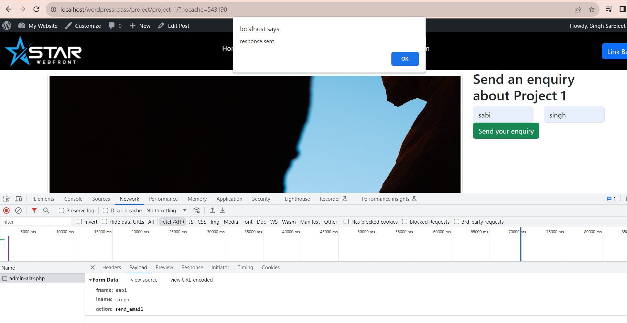

If you now send the response using wp_send_json_success() method. You can display it in the console in the script.

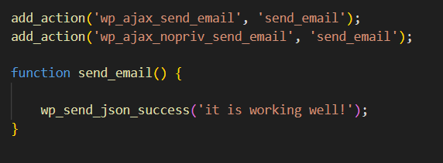

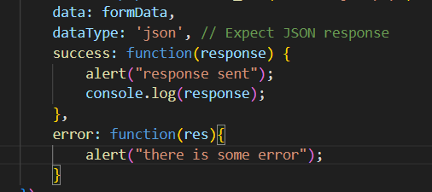

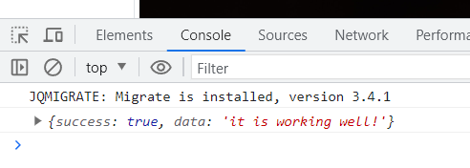

Now we can process the data in the functions.php which we sent to it using AJAX and then we can return the response after working on data.

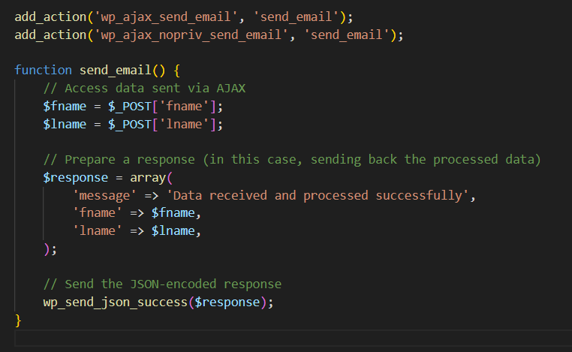

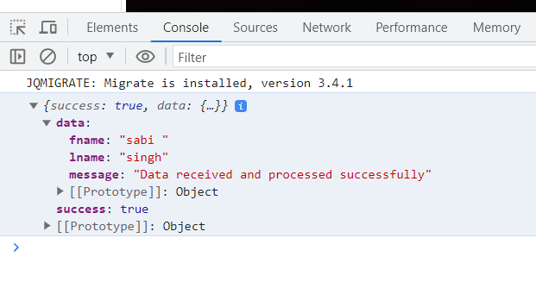

Now you can use this data as you want like javascript object.

I have created a div with id myinfo just under the form and dsiplay the first name there.

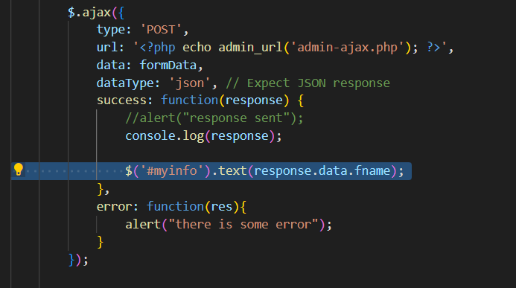

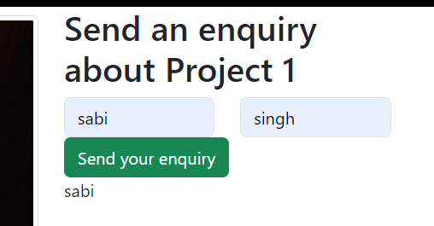

Another way is using the serialized method of javascript, you can use that also to get the form data in one single line using the form id and serialize method.

Then you can append the action in the data parameter of AJAX request like in the pic.

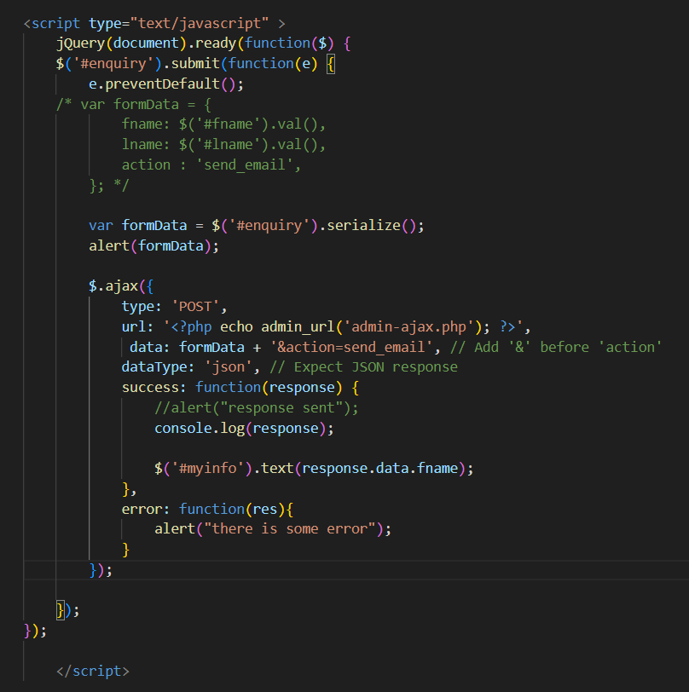

Everything rest will work as same before.

To send data to your gmail account. Use the following code, we will use wp_mail function of wordpress, it is always send slong with header.

<https://developer.wordpress.org/reference/functions/wp_mail/>

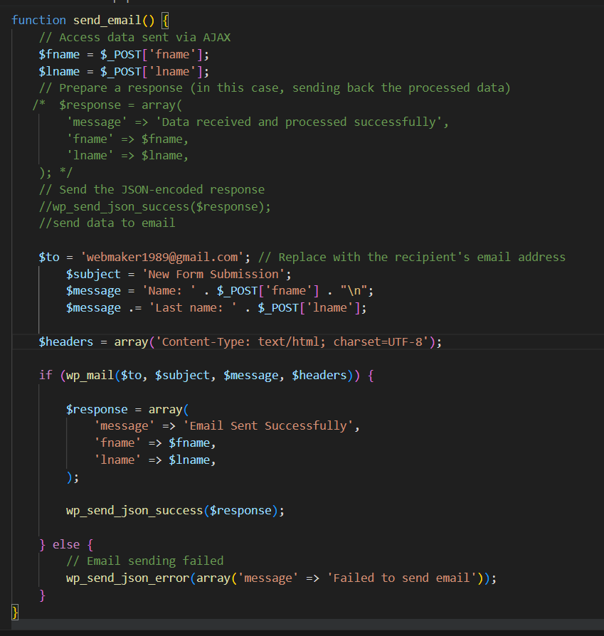

Learn about header in next to next page.

**Points to be remembered: If you are having jquery error that it is not recognizing. Make sure you have added jquery properly in functions.php file.**

**If you are using this file as a template page in wordpress theme , make sure the head is added. For ex .**

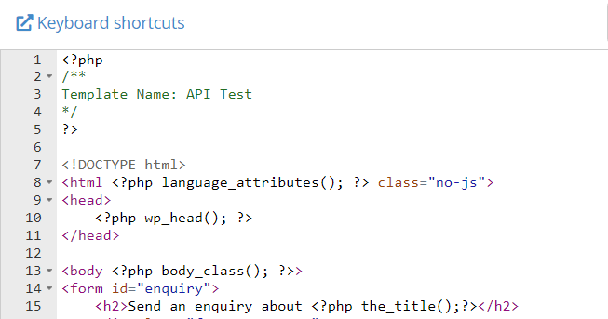

Or

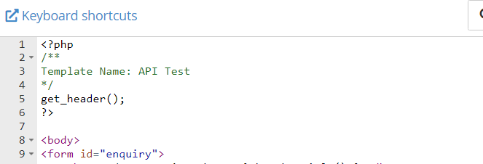

**$headers = array('Content-Type: text/html; charset=UTF-8');**, is typically used when sending emails in PHP using the **wp_mail()** function or other similar email-sending functions. It's used to set the content type and character encoding for the email message.

Here's an explanation of what this line does:

1. **Content-Type Header**: The **'Content-Type: text/html; charset=UTF-8'** header indicates that the email's content is in HTML format (**text/html**) and that it uses the UTF-8 character encoding (**charset=UTF-8**).
   * **text/html** specifies that the email content should be treated as HTML, allowing you to include HTML tags and formatting in the email body. This is common when sending emails with HTML-based content, such as newsletters or formatted messages.
2. **Character Encoding (UTF-8)**: Setting the character encoding to UTF-8 (**charset=UTF-8**) is important for ensuring that the email can correctly display international characters and symbols. UTF-8 is a widely used character encoding that supports a broad range of characters from various languages and scripts.

Including the **'Content-Type: text/html; charset=UTF-8'** header is essential when you're sending HTML-formatted emails or emails that contain non-ASCII characters (e.g., accented letters, special symbols) to ensure that the email clients can properly render and display the content.

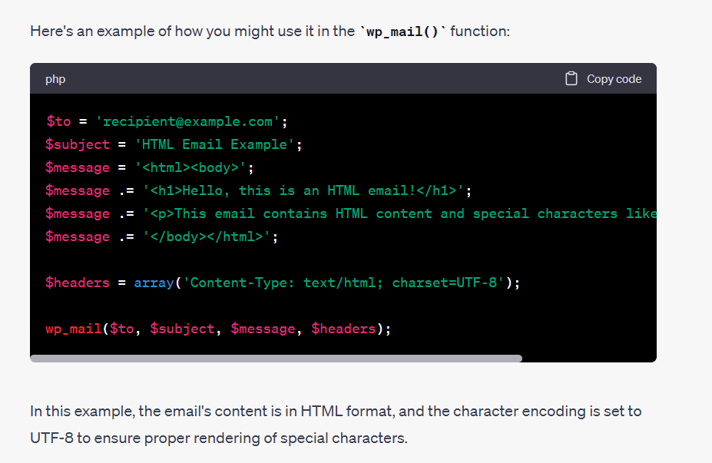

In header, you can append more data, check this video.

<https://www.youtube.com/watch?v=LYvx_L9ESn0&list=PLgFB6lmeXFOpHnNmQ4fdIYA5X_9XhjJ9d&index=13>

**Adding Nonce for security:**  For security you can add nonce when send the form data and create a condition in fucntions.php to see if nonce is matching.

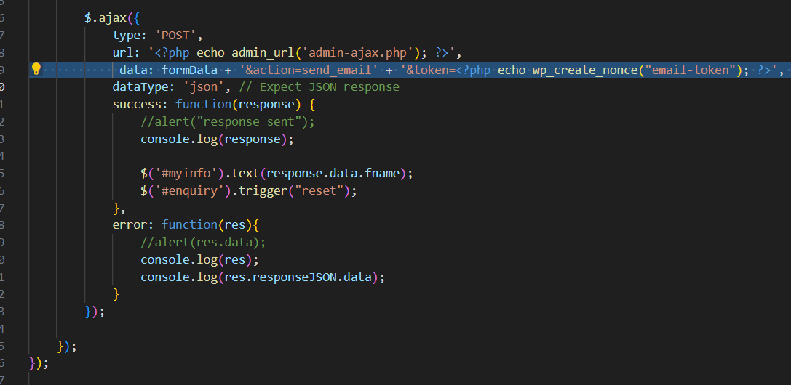

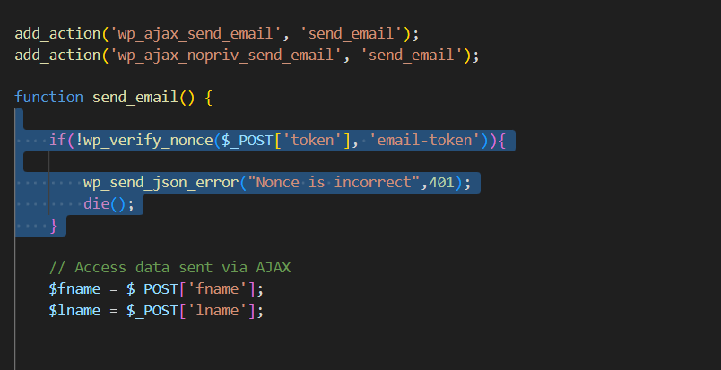

<https://gist.github.com/luetkemj/2023628>

<https://www.youtube.com/watch?v=rw3jRE8IslM>

For now you were just using the simple loop to display all the posts in the loop.

But if you want to display the posts from different categories or different authors then you cannot do it with the simple loop.

Lets say if you want to create three containers, one to display the recent posts, one to display the posts from a specific category, and one anything like some other category.

In that case we cannot do that with simple loop, we will use the wordpress class WP_QUERY.

So we have created here a separate template and attach it to inde.php file.

Here we are using wp_query to display the posts related to the category number 4.

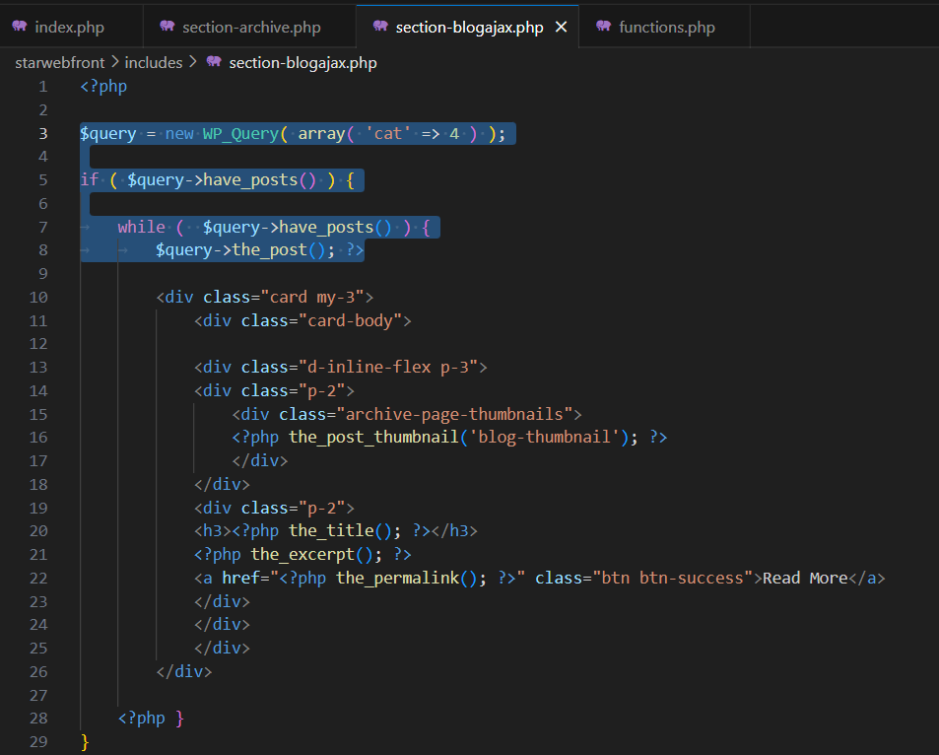

You need to make a small change, instead of have post, use if the $query have posts, while query have posts and display the $query->the_posts().

Here the $query variable is returning an object we are displaying the values based on that you can add more parameters. It will be better to create a separate array as arguments and pass it to the class.

You can pass many parameters check them from the github account. In the following example, we have a created a scheduled post in the category 4 and it is displaying.

**Make sure create the arguments variable first then create the query.**

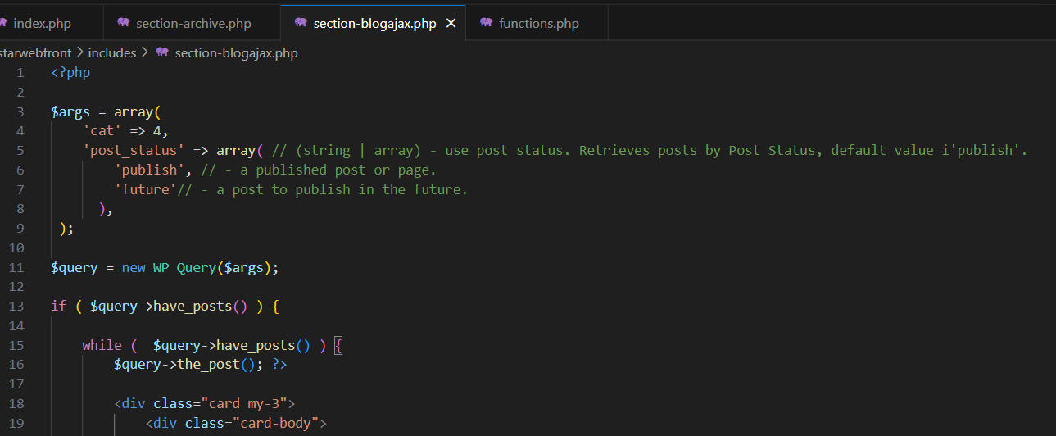

It is very important to use wp_reset_data(); after the wp_query finish.

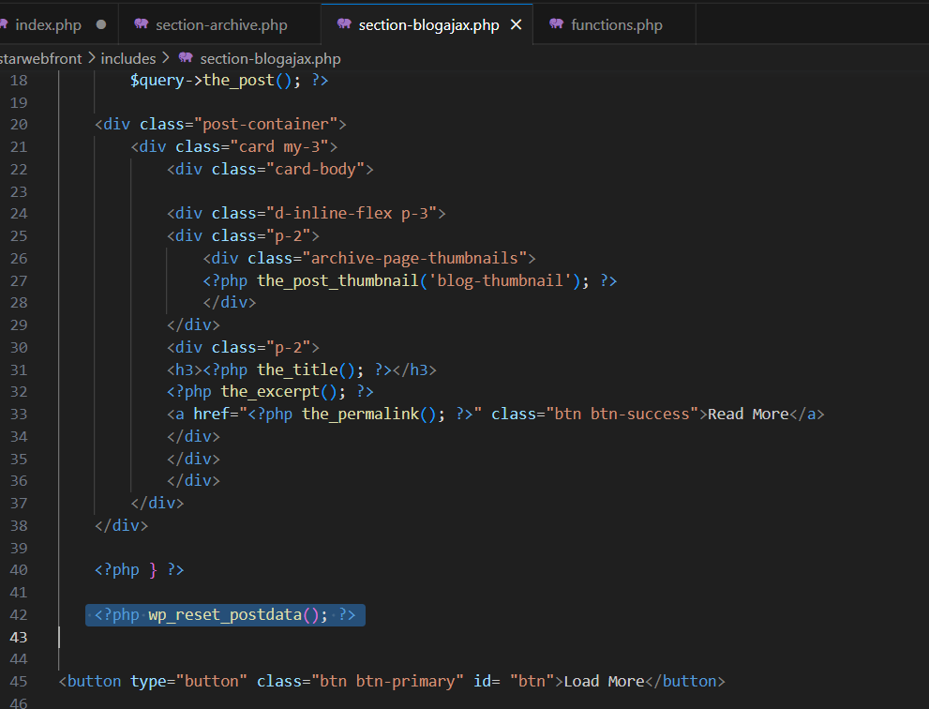

Load more ajax posts:

In the page we will create a load more button and on click we will load more posts based on the page number using Wp_query paged parameter which is based on the page number that is showed in the url.



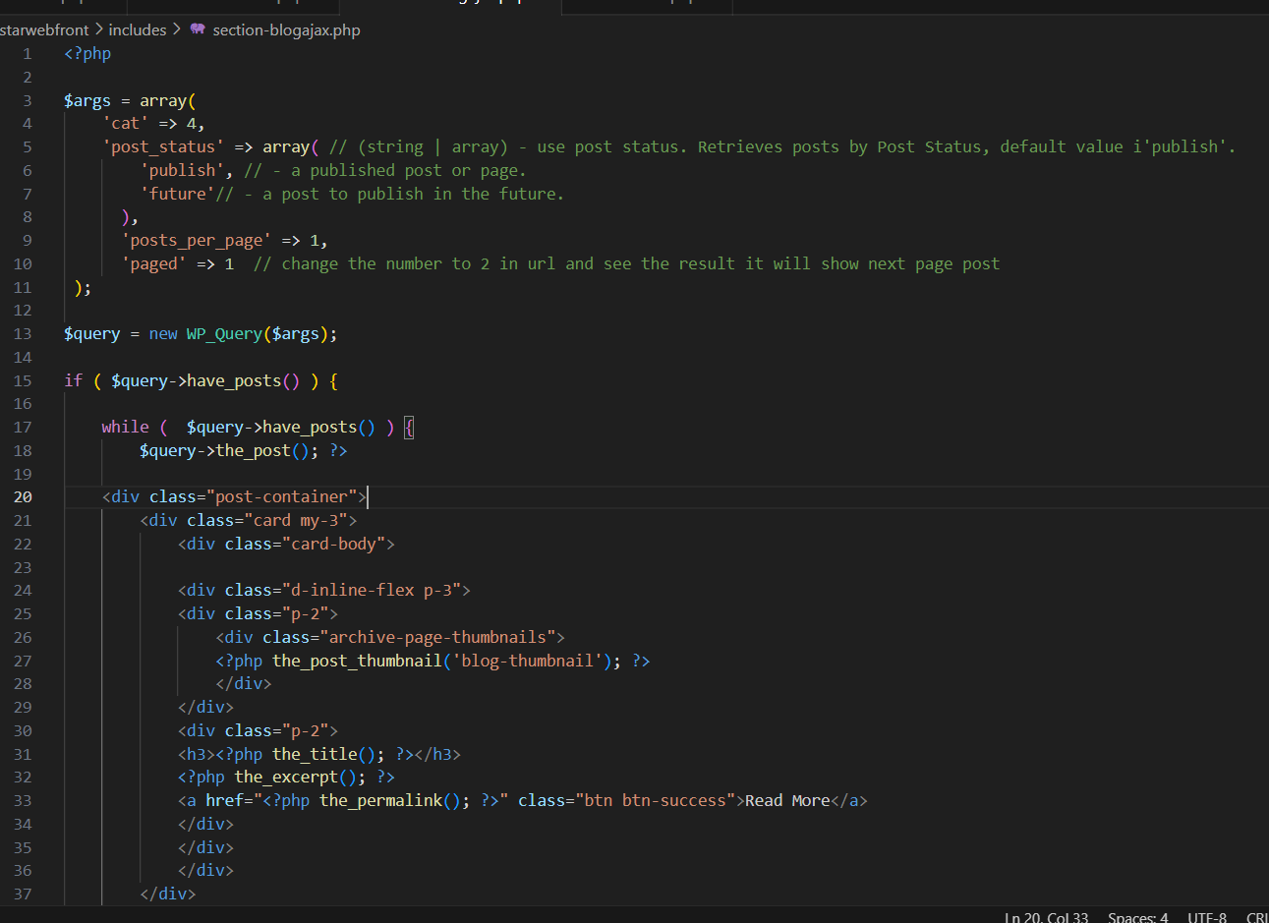

Then write ajax method at the bottom of the page, we will use the same way as we used in the form ajax.

On clicking load more button, we will increment the pageNumber and will send it with action to the functions.php file, where it will process and display the data.

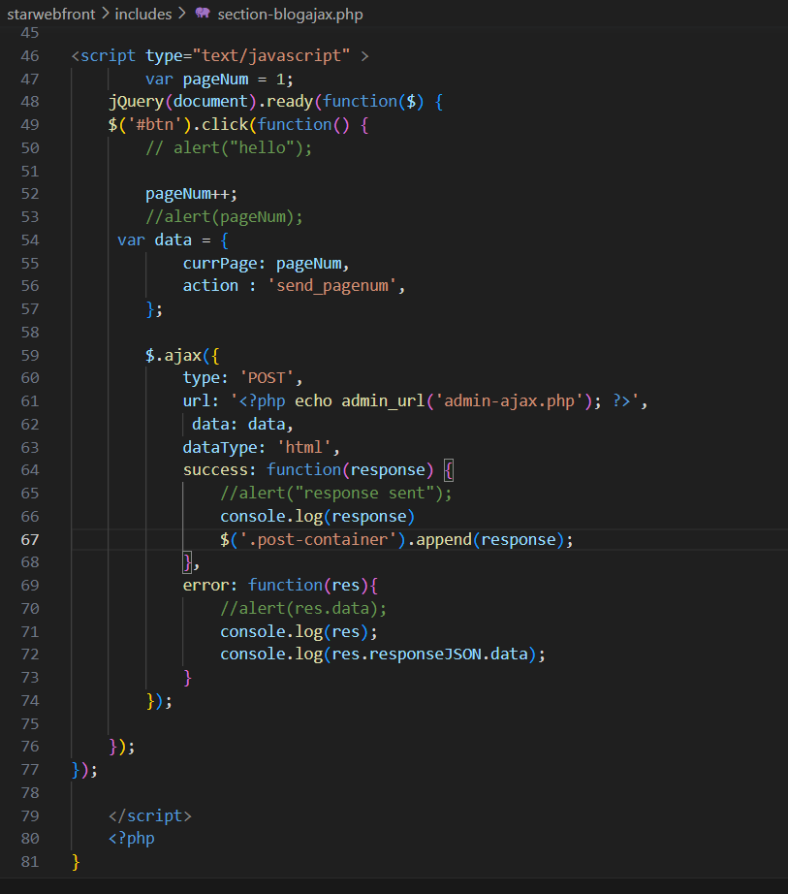

In fucntions.php, we will create the two hooks and add the action as callback function as we did in the formajax.

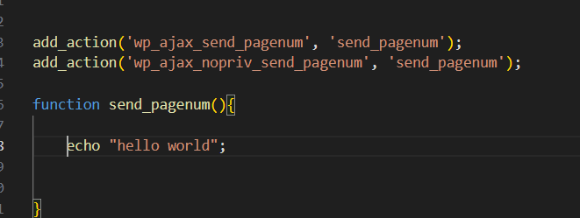

You can check the response in Network tab. Now you just need to copy paste the same data that we are printing in the template file in this function and it will return it to the ajax. Then using jquery you can print it.

Only thing is that we get the pageNumber using post method.

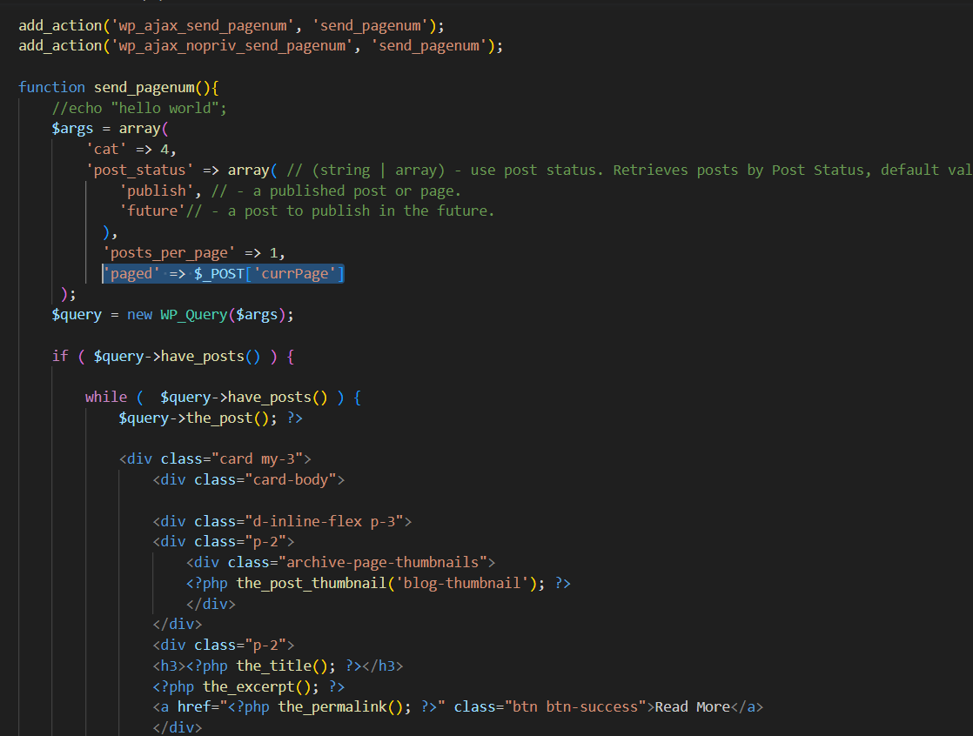

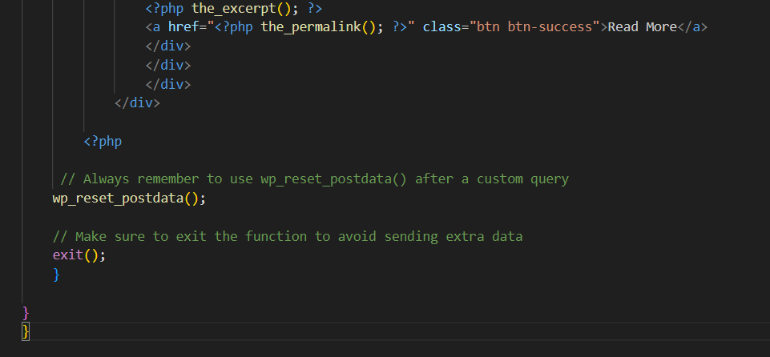

Don’t forget to add wp_reset_postdata() and exit to stop displaying empty data.

**Now we will see how we can hide Load More button when there are no more posts to display.**

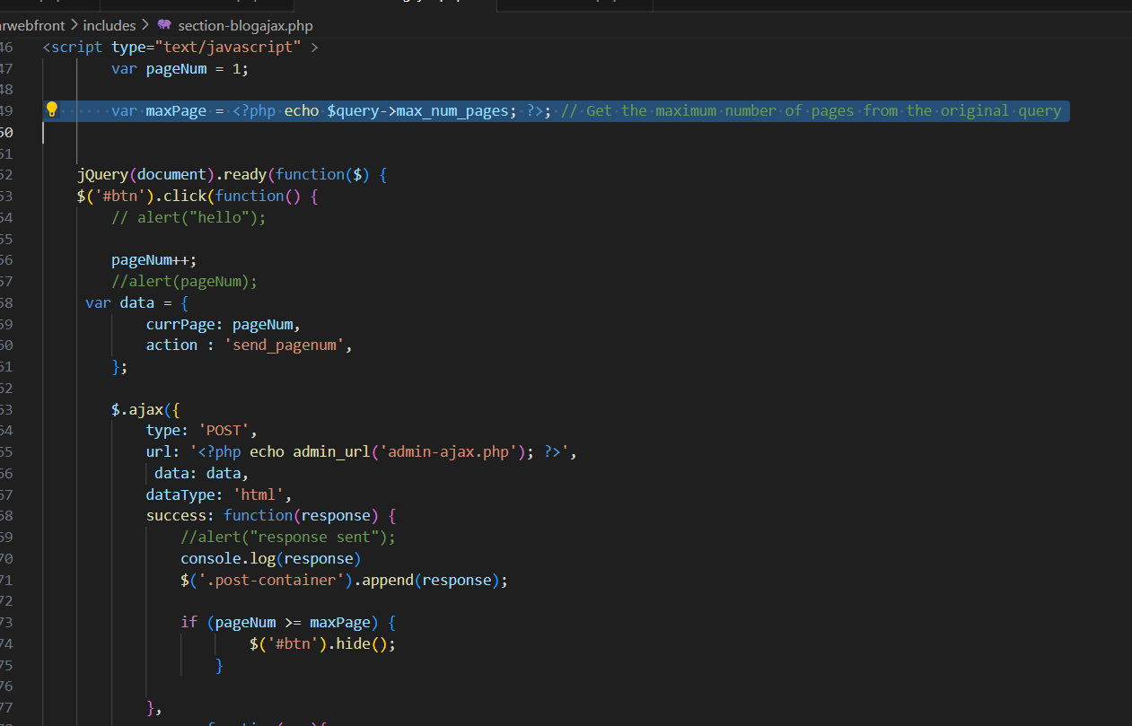

You can also send nonce if you want

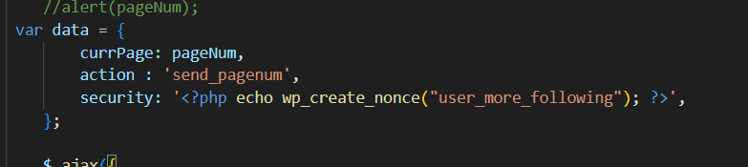

And verify in functions.php

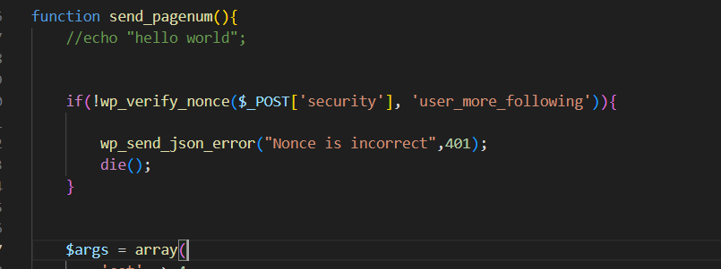

To make it look better, you can create a template file for the card section so that you can grab that in one single line

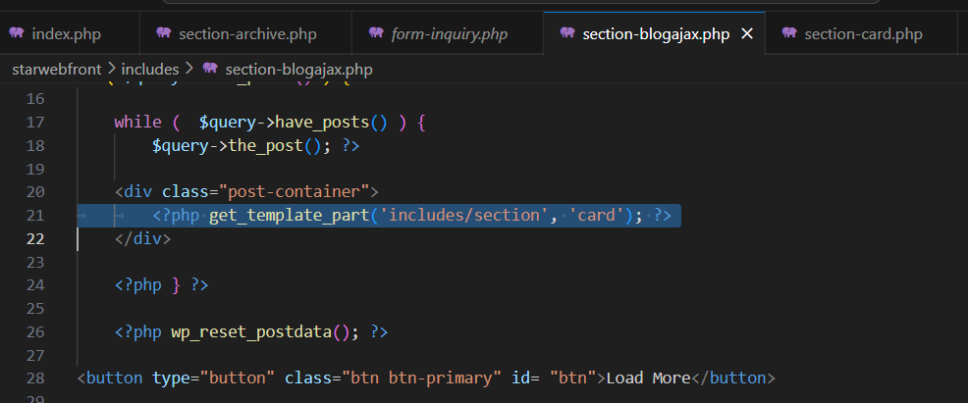

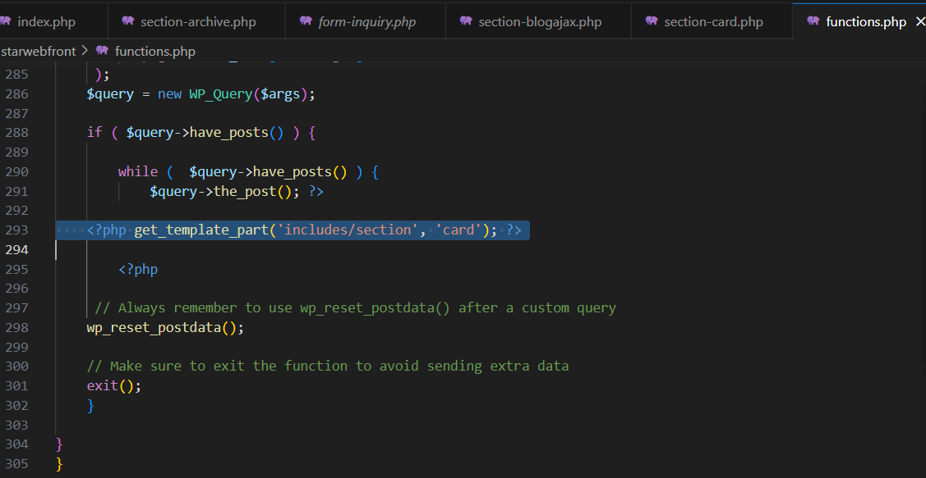

<https://weichie.com/blog/load-more-posts-ajax-wordpress/>

**Localize scripts:** For now we were using javascript in the template file, but to keep the clean code we will add a separate javascript file in the assets folder and put the script code there.

But we cannot use the php tags and statements in the script file. So in that case first we will have to register the script and then localize the script and pass the variables through that.



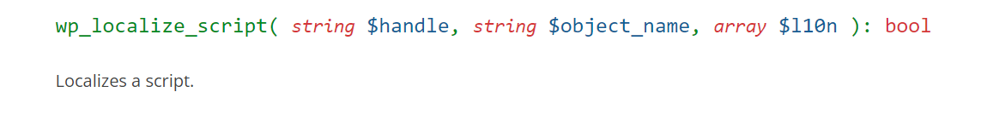

We have created a file named loadmore.js and added js code in that but you can see that it will give you error as we can not use php as it is. Remove the script tags now.

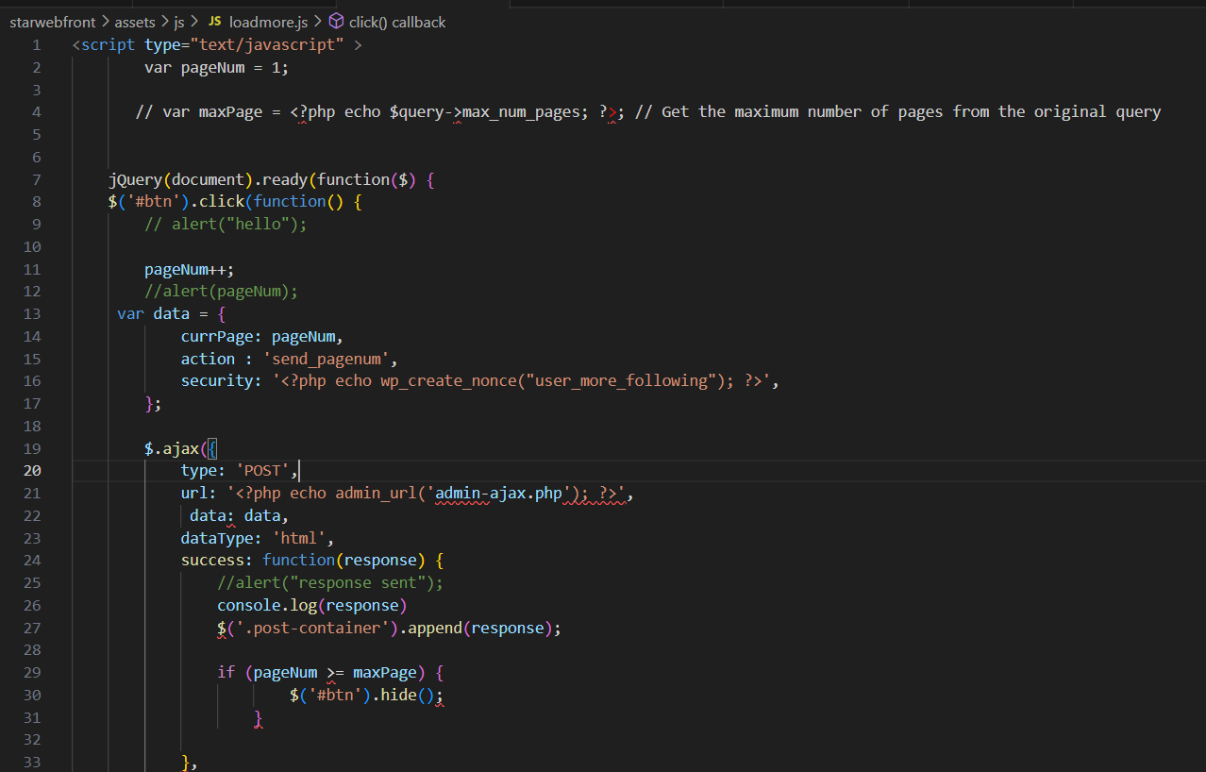

So in that case first we will register javascript in functions.php and pass these values as the javascript object when localize the script.

**When localize scripts make sure handles of registering and localizing scripts should be same.**

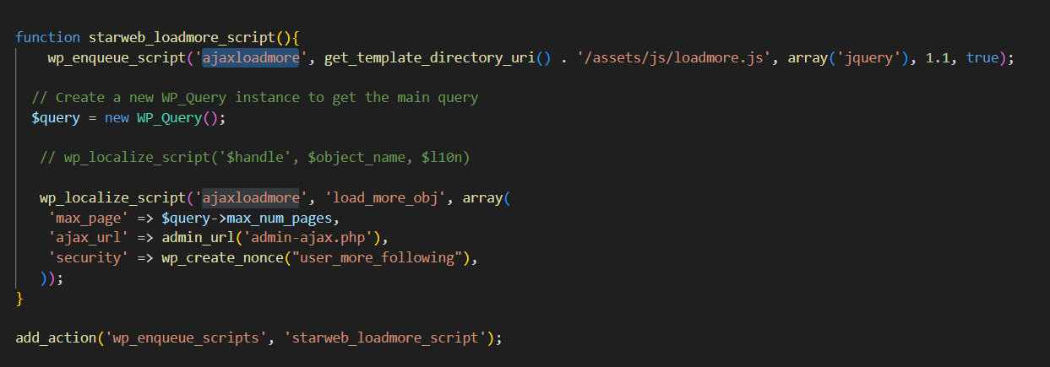

We have just used the same php functions that we defined in the js file and now we will access these variables in the js file by using object_name.property . In this case, object name is load_more_obj.

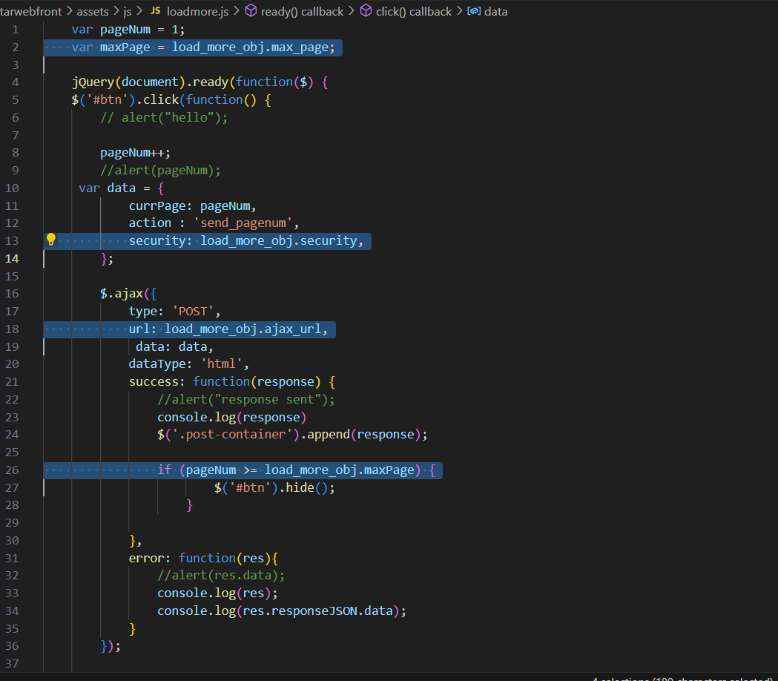

Wordpress Shortcodes : Remember always use return instead of echo in shortcodes.

Wordpress SHortcodes: <https://www.smashingmagazine.com/2012/05/wordpress-shortcodes-complete-guide/>

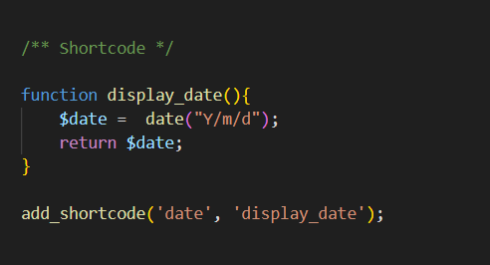

Shortcode has two parameters, shortcode name and funtion name.

If you wan to display shortcode in template file use:

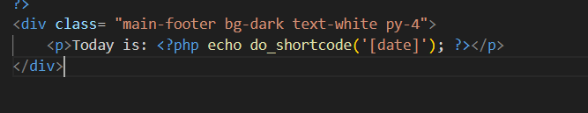

To display in the page, just use: [date]

Shortcode with attributes:

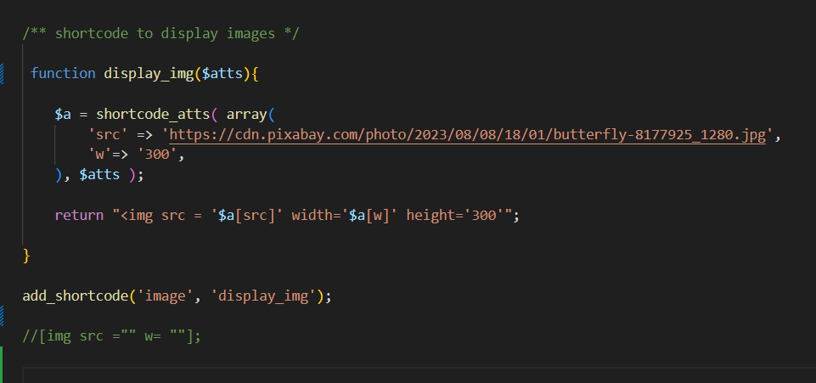

You can pass the attributes to make the shortcode dynamic.

<https://developer.wordpress.org/reference/functions/shortcode_atts/>

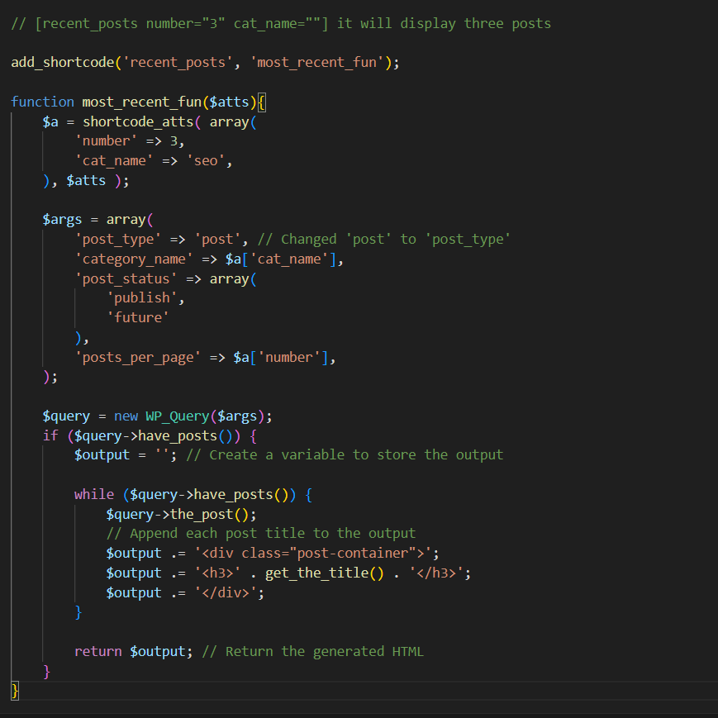

Shortcode to get API data:

Three main functions are used:

 $user_data = wp_remote_get('https://jsonplaceholder.typicode.com/users');

$responseBody = wp_remote_retrieve_body($user_data);

  $result = json_decode( $responseBody );

Then use foreach loop :

$output = '';

   foreach( $result as $data){

    $output .=  $data->id . " " . $data->name .  "<br>";

   }

return $output;

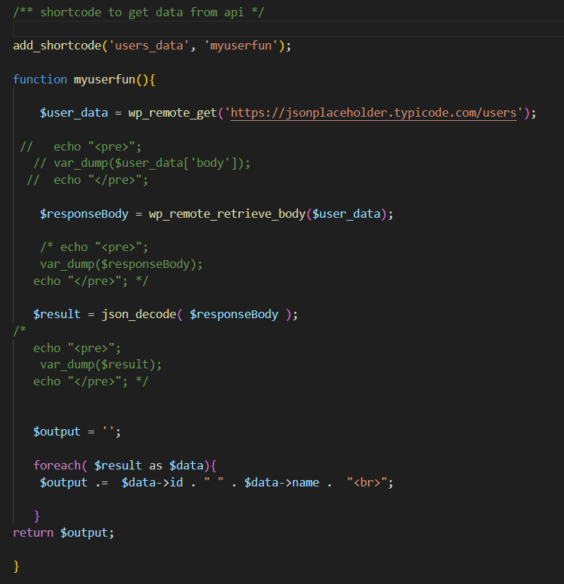

Displaying data based on id attribute, we don’t need foreach loop as we are going to display the data of one person.

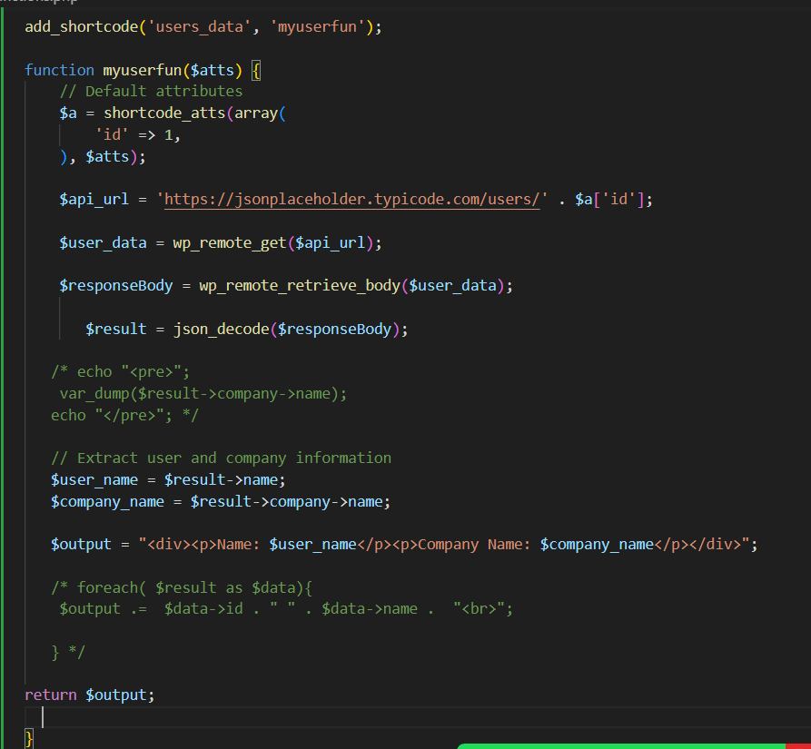

Rest API :

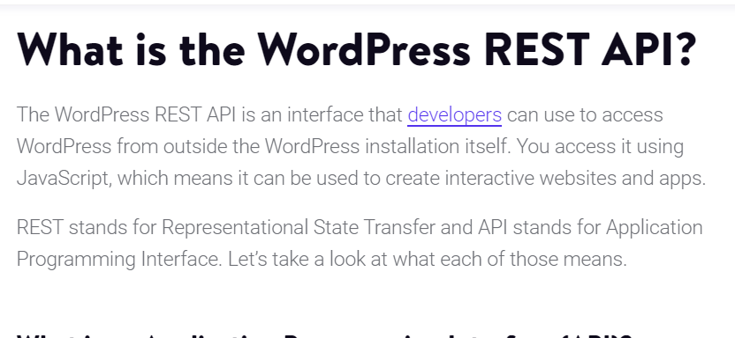

<https://kinsta.com/blog/wordpress-rest-api/#what-is-the-wordpress-rest-api>

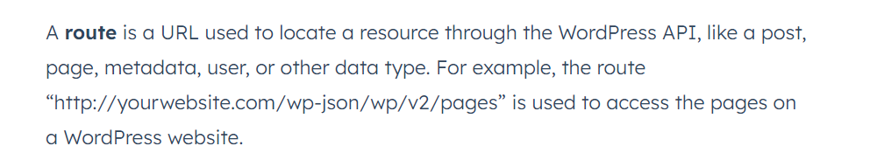

Better notes: <https://blog.hubspot.com/website/wordpress-rest-api#what-is>

Add custom css font family in the theme :

Download fonts from fonts.google and extract the files. Use only ttf or otf files.

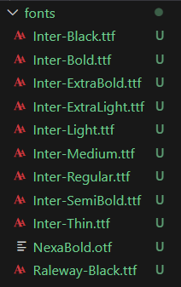

Create a folder inside your themes wherever you want mostly isndie the assets and name it something like fonts.

Then use the font-face property to add them.

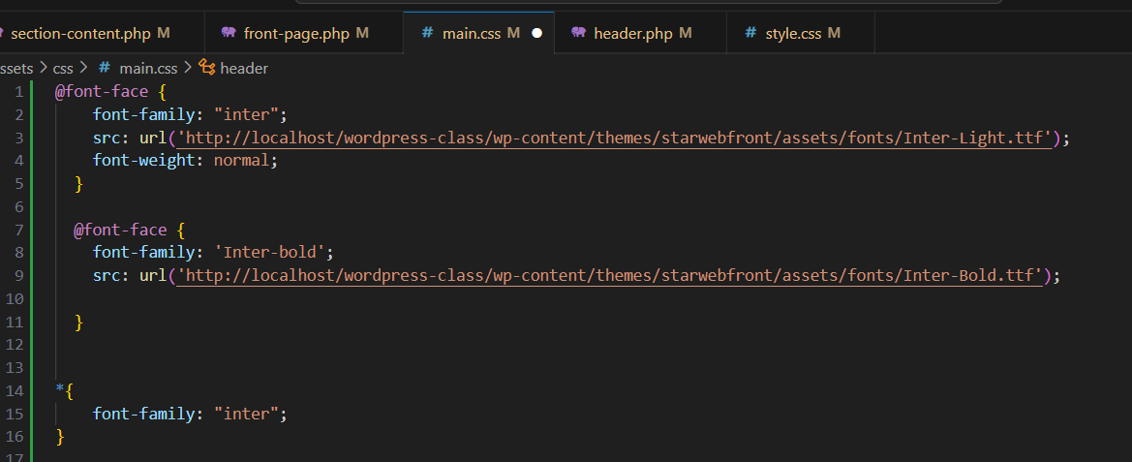

Make sure in the path give your website’s address and then the directory.

Adding Slick Slider to the wordpress:

We need two css and one js file of slick. You can either download and save inside the css and js directory or you can use it as a cdn link.

Then you can add it in the enqueue script hook in the main file or you can use wp_footer hook to enqueue. CSS files should be in the header whereas js files should be in the footer.

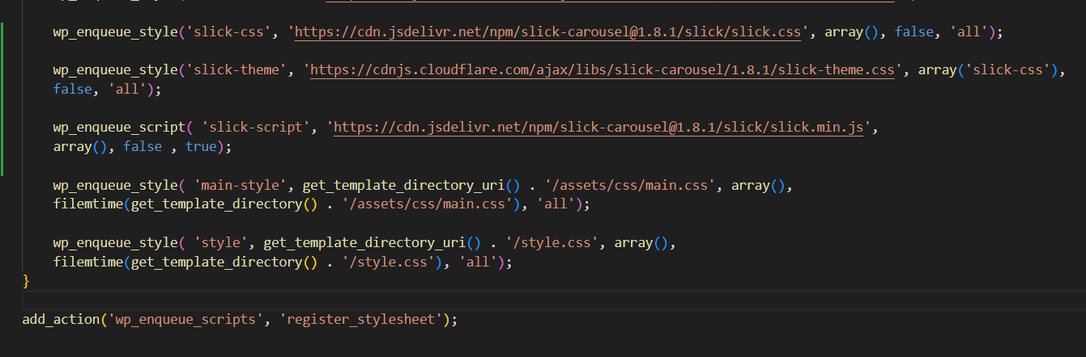

For the version, we use false because it can change at times so we will keep it updating.

Then for the javascript to be in the footer we use , true which is by default. The argument is in_footer

Second way of adding it is

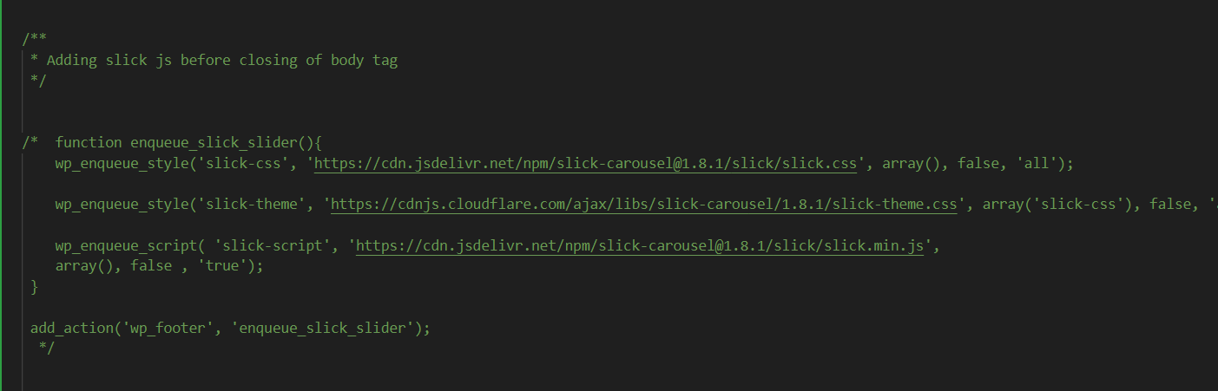

Same code just put it inside the wp_footer instead of enqueue.

Then you can use the slick slider setting either in a separate js file or inside functions.php file.

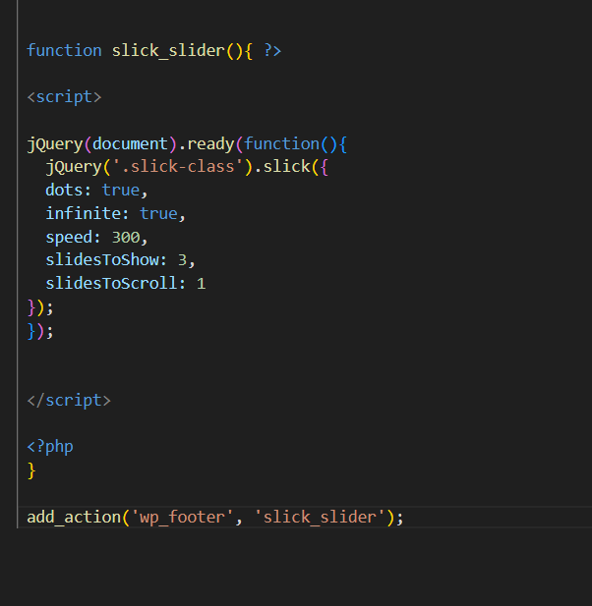

The use the slick class on whatever block you want to apply it.

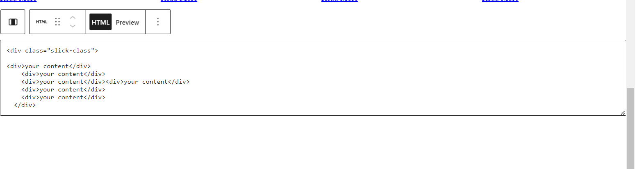

<https://imranhsayed.medium.com/slick-slider-wordpress-without-plugin-slick-carousel-ef2394c737ef>

**Ajax using fetch in javascript:**

Create a page to display three posts first   
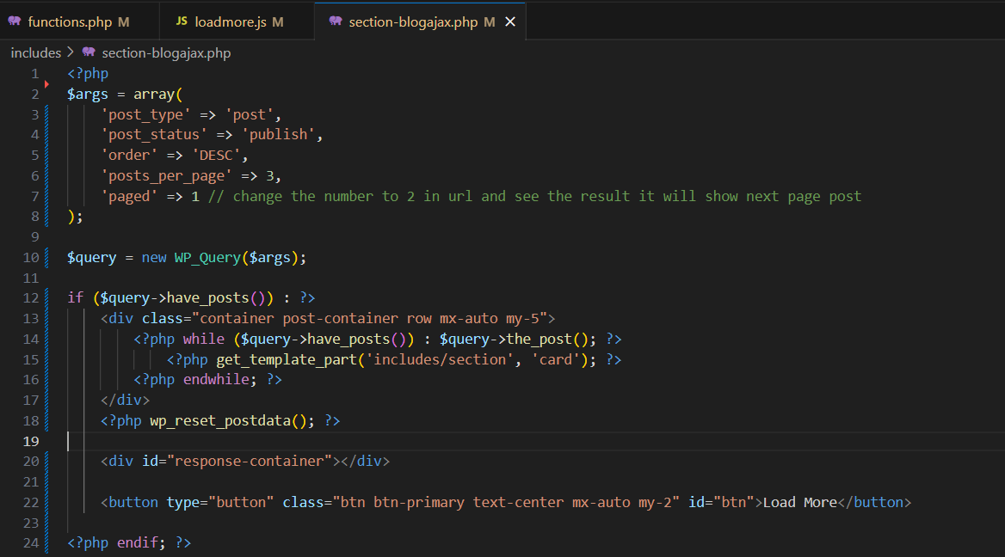

Then we will create a javascript file where we will cretae our ajax request to fetch data. As we are creating a separate file for javascript, we need to make it localize also in functions.php

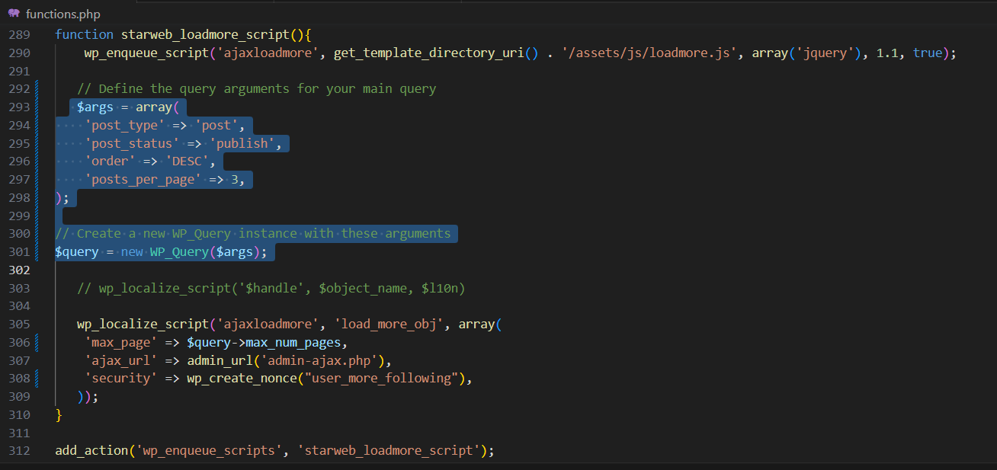

Here we use these args, just to get total number of pages we have for the posts so that we can use this variable later on to hide load more button by comparing. You can skip it for now. Rest of the data we can get in the loadmore.js file in following way. New URLSearchParams is very important here.

<https://www.youtube.com/watch?v=BOQ9mmUd3dI>

secondally for the page we set, currpage = 2, as we are already displaying the page 1 , when we show first three posts. So we initiate it from page 2. So that it does not repeat the first three posts.

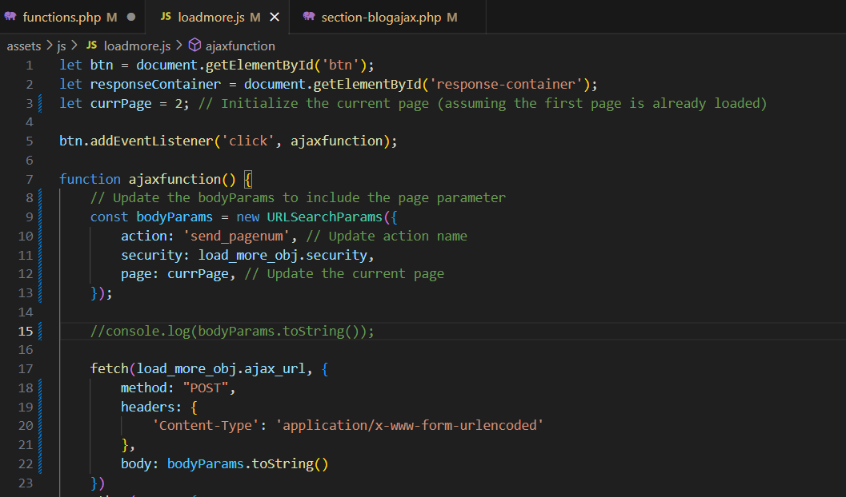

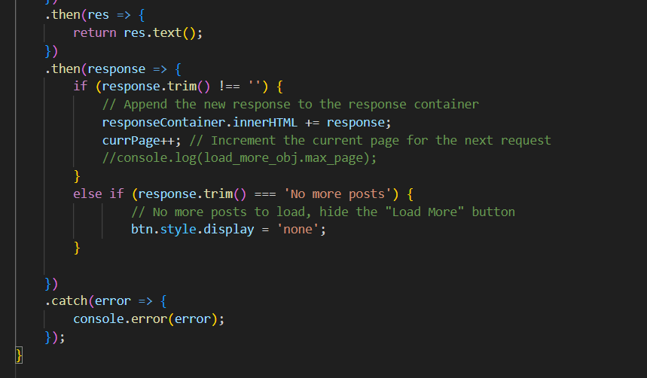

Rest of the functions.php file is below.

